
Request for Absence Decision Form

BEFORE COMPLETING THIS FORM PLEASE READ THE NEW LAW FROM THE DfE ON THE BACK OF THIS FORM

Dear Parent/Carer

I have parental responsibility for the following student and I am requesting authorisation for him/her to be absent from school as detailed below:

NAME OF STUDENT: ........................................................... YEAR............CLASS…………………

ABSENCE DATES: From ......... / ......... / ......... to ......... / ......... /......... (Inclusive)

HOLIDAY DESTINATION:……………………………………………………………………………………

TOTAL SCHOOL DAYS TO BE ABSENT: .............................

The reason that this absence is being requested during term-time is because:

............................................................................................................................................................

............................................................................................................................................................

Signed: ...................................................(Parent/Carer) Print Name:……………………………………..

Date:…………………………………….

Name(s) of brothers/sisters in Primary School

Name: .............................................................. School...............................................................

(PARENTS/CARERS PLEASE ALSO COMPLETE YOUR PART OF THE REPLY SECTION BELOW)

----------------------------------------------------------------------------------------------------------------------------------------------
REPLY SECTION

NAME OF STUDENT: .........................................................................YEAR……….FORM…………

REQUESTED ABSENCE: From ......... / ......... / ......... to ......... / ......... /......... (Inclusive)

HEADTEACHER’S DECISION

Your request is authorised on this occasion
*Your request is NOT authorised on this occasion because:
* Parent/Carer may receive a Fixed Penalty Notice if you take your child out of school

............................................................................................................................................................

............................................................................................................................................................

Signed: ......................................................................... Date: …………………………………

(If not the Headteacher’s signature then the person signing this form is authorised to do so.)

Copies to: - Parent / Teacher/ Abs.Holiday File

Important Information Regarding Holiday Requests 2022-23

Dear Parents and Carers

Holidays taken during term time

Please find below the latest guidance from the Department for Education which the Local Authority advised all schools to share with parents and carers.

The Government discourages the taking of holidays in term time. Evidence shows that children who miss school do not achieve as well as those who attend regularly.

As of September 2013, the law has restricted a Head Teacher’s ability to authorise holidays during term time. Head Teachers are now only empowered to approve a leave of absence when it is requested in advance by the parent or carer with whom the child resides and when circumstances of the requested leave are ‘exceptional’.

From September 2017 should you choose to take a holiday for 5 consecutive school days or more during term time the Local Authority will be informed as this will constitute an unauthorised absence. A Fixed Penalty Notice will then be issued in accordance with section 444 of the Education Act 1996.

The law stipulates that the current penalties payable by parents are £60 when the penalty is paid within 21 days and £120 when the penalty is paid within 28 days. This penalty is per parent/carer per child.

If the fixed penalty is not paid this could lead to you being prosecuted in the Magistrates’ Court.

If you feel this decision has not taken into account any relevant exceptional circumstances, please contact the school immediately for further discussion.

As a school, we fully appreciate the financial difficulties that some parents face when booking holidays, particularly during school holidays however, there is an expectation that all schools in Cheshire West and Chester introduce firm policies and stringent checks to ensure that there is a significant reduction in the number of absences during term time.

I would like to take this opportunity on behalf of the school to thank you for your full support in this matter by not taking your child out of school during term time.

This new legislation will bring about increased attendance and improving standards in our borough’s schools.
Further information can be obtained from www.dfe.gov.uk

Yours sincerely
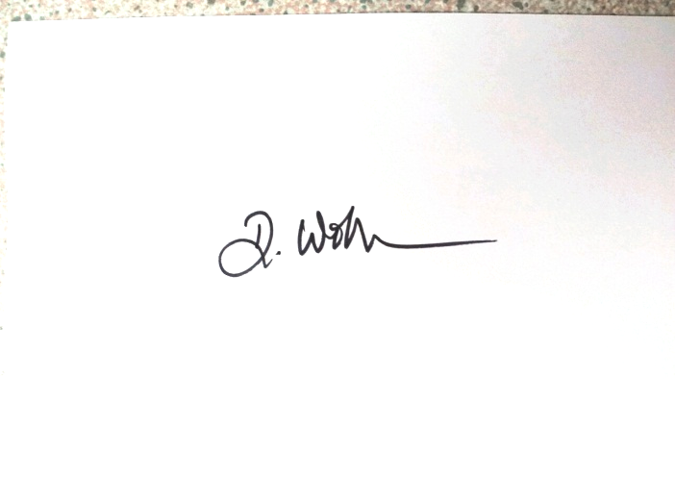

Dave Williams
Head Teacher



