KNOWLEDGE ORGANISER
How do Christians use the Bible to help them with their lives?

Key Vocabulary
5 Fingers | Christianity, Christian, Bible, Hebrew, Aramaic, Greek, Church
Bible | The book of sacred writings accepted by Christians as coming from God.
Sacred | Something that is sacred is believed to be holy and to have a special connection with God.
Verses | One of the short parts of a chapter in the Bible.
Christian | Christians are people who believe that Jesus Christ is the Son of God, and follow his teachings and those of the Christian Churches.
Wisdom | Wisdom is the knowledge or learning gained over time.
Testaments | Either of two main divisions of the Bible.  Old Testament: Before Jesus’ birth.  New Testament: After the birth of Jesus.
Parable | A Parable is a simple story with a moral or a story told to teach a lesson.
Prior learning
- Why is the Bible a special book for Christians? – Y2
Future Learning
- How did Jesus teach about God and values through parables? – Y4
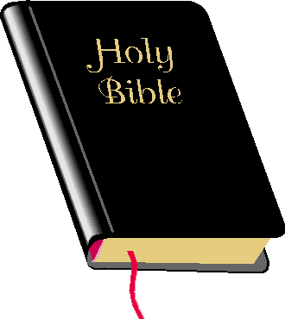
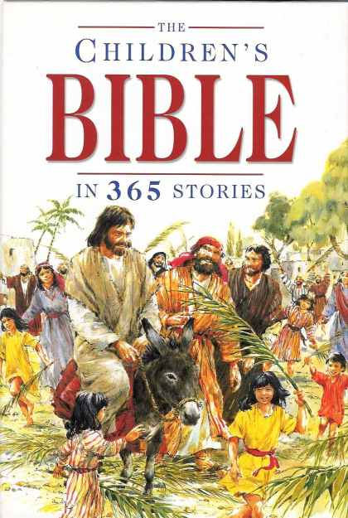
Key Artefacts and Symbols
Key Stories
Different literature in the Bible:
Poetry, Songs, Laws, History, Prophecy, Gospels, Biographies, Proverbs, Stories, Prayers and Teachings.
Parables or Miracle Stories:
The Good Samaritain, The Story of the Lost Sheep
The Prodical Son The Lost Coin

Our Enquiry Steps:
What is a sacred text? Is the Bible a Best Seller?
What is in the Bible and who wrote it?
How do you find particular verses in the Bible?
Why are there different kinds of Bibles?
What does the Bible mean to a Christian?
How is art used in the Bible?

