Prior learning
Future Learning
How do Jews show faith through practises and celebrations? – Y2
How do Jews demonstrate their faith through their communities? – Y6
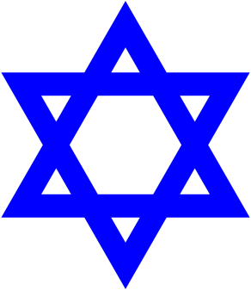
KNOWLEDGE ORGANISER
What do Jews believe about God?

Key Vocabulary
5 Fingers | Judaism, Jews, Torah, Hebrew, Synagogue.
Torah | The first 5 books of the 24 books in the written Torah.  The Law of God revealed to Moses.
Yad | A pointer used to point to the text when reading from the Torah. Can be made from silver or wood, has Star of David symbol on it.
Joseph | He was the son of Jacob and Rachel. He lived in Canaan with his 12 brothers. He was his father’s favourite son and was given a special coat.
Miriam | Moses’s big sister who watched over him in the basket in the river. She saw the Egyptian Princess pick him up and fetched her Mum to look after him for the Princess.
Moses | Miriam’s little brother. Led the Jews out of Egypt. Was given the 10 Commandments by God on Mount Sinai.
Commandments  (Mitzvot) | Special rules given by God to his people. Christians follow 10 Commandments, but Jews have 613 Mitzvot (Commandments) to follow.
Courage | To be able to do something that frightens you. Another word for bravery.
Slavery | When a person owns another human being. The slave has to work hard and do as they are told. They are not free to do what they want.
Respect | A positive feeling shown towards someone or something important.
Holy | Something very special because it is connected to God.
Our Enquiry Steps:
Why is the Torah important for Jews?
What do Jews believe about God?
Who was Joseph?
How did Miriam show courage and truthfulness, and choose between right and wrong?
Which rules are important for Jews?
What do Jews believe about a creator God?
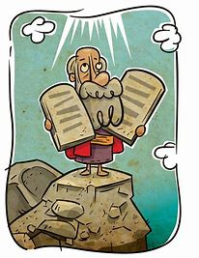
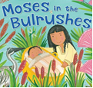
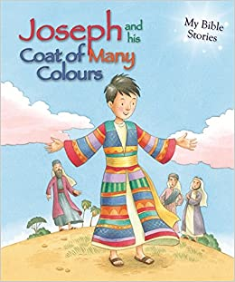
Key Stories
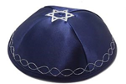
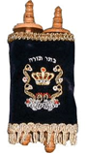
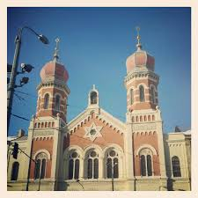
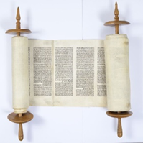
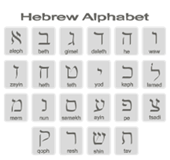
Key Artefacts and Symbols

