Prior learning
- What do Jews believe about God? – Y2
- How do Jews show faith through practices and celebrations?
Future Learning
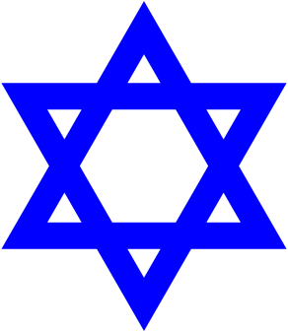
KNOWLEDGE ORGANISER
How do Jews demonstrate their faith through their communities?

Key Vocabulary
5 Fingers | The place where Jews meet to worship God (church for Christians). It means ‘meeting place’ in Greek.
Synagogue | that Jews believe that the Torah is God's way of communicating with them. It is his most precious gift to them. (The first 5 books of the Christian Bible)
The Torah | The most important thing inside a synagogue is the ark, or cabinet, that holds the Torah scrolls.
The Ark | A raised platform in a synagogue from which the Torah is read.
Bimah | Commemorates the revelation of the Torah on Mt. Sinai given to Moses and the Jewish people. (The Ten Commandments—Christianity)
Shavuot | Burning before the ark. (In Christian churches the sanctuary lamp, also called a chancel lamp, is placed before the tabernacle to signify the presence of the Lord/Blessed Sacrament.
Ner tamid, “Eternal Light” | Celebrates the freedom of the Jews from slavery in ancient Egypt. Moses ( the most important prophet in Judaism but also an important prophet in Christianity, Islam and the Bahá'í Faith.
Pesach/Passover | This is the seder plate, and each food is symbolic for an aspect of Passover: A roasted shank bone represents the Pescah sacrifice, an egg represents spring and the circle of life, bitter herbs represent the bitterness of slavery, haroset (an applesauce-like mixture with wine, nuts, apples, etc.)
Sedar | Commemorates the years that the Jews spent in the desert on their way to the Promised Land, and celebrates the way in which God protected them under difficult desert conditions. Sukkot is also known as the Feast of Tabernacles
Sukkot | The place where Jews meet to worship God (church for Christians). It means ‘meeting place’ in Greek.
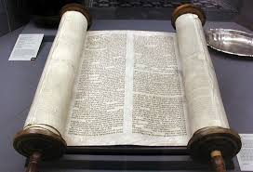
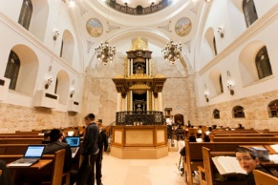
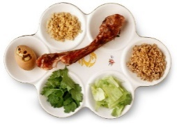
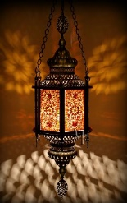
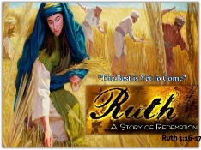
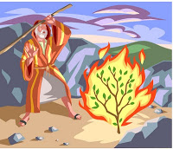
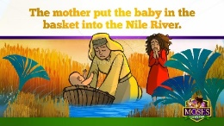
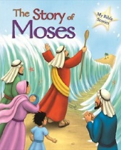
Key Artefacts and Symbols
Key Stories
Our Enquiry Steps:
What happens at a Synagogue?
What happens at Pesach?
What is Sukkot?
How do Jews remember the giving of the Torah? Shavuot
What rules for Jews are there to follow in the Torah?
What happens during the life journey of a Jew?

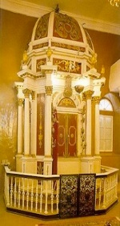
Bimah

