Prior learning
- How and why are Allah and Muhhamed (PBUH) important to Muslims? – Y2
- How do Muslims express new beginnings? – Y2
- Why are the Five Pillars important to Muslims? – Y5
Future Learning
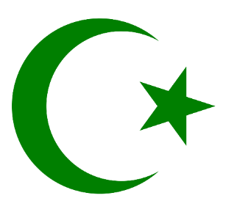
KNOWLEDGE ORGANISER
How is the Muslim faith expressed through family life?

Key Vocabulary
5 Fingers | Islam, Muslims, Qur’an, Arabic, Mosque
Ramadan | Ramadan is the ninth month of the Islamic calendar, when Muslims fast during daylight hours.
Eid (al-Fitr) | This festival marks the end of Ramadan (the Muslim holy month of fasting). It is a time of official receptions and parties, when friends geet each other, presents are given, new clothes worn and graves of relatives are visited. Large feasts help Muslims celebrate.
Halal | Meaning permissible or lawful. Refers to an animal or its meat slaughtered or prepared in the manner perscribed by Islamic law.
Haram | Refers to any act that is forbidden by Allah. Muslims believe that follow these define the morality of human action.
Madrasah | A school or college, especially a shcool attached to a mosque where young men study theology.
Ummah | Arabic word meaniing ‘community’.Refers to the whole of Islam,each member bound to all the others by the special religious ties from which they find meaning.
Akhlaq | Refers to the ethics, good conduct and moral character of a person. ‘The only reason why I am sent is to perfect good Akhlaq.’
Islamophobia | Fear, hatred of or prejudice against the Islamic religion or Muslims generally.

KS2 Religious Education - BBC Bitesize
Useful Links
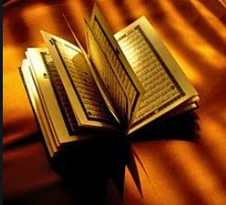
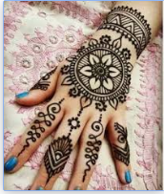
Key Artefacts and Symbols
Our Enquiry Steps:
What do I already know about Islam?
What is Ramadan? How is Eid celebrated?
What is Halal?
How does Muslim family life show their belief in the Qur’an?
How do modern Muslims follow their faith today?
How can we tackle Islamophobia?
Does the media show Islam in a balanced way?

