

**KNOWLEDGE ORGANISER**

**What are some of the differences and similarities within Christianity locally and globally?**

|  |
| --- |
| **Prior learning** |
| What does it mean to belong? – Y1  Who was Jesus and why is he important to Christians today? – Y2  How do I understand different Easter concepts – Y4  What can we learn from Christian religious buildings and music? – Y6 |
| **Future Learning** |
|  |

|  |  |
| --- | --- |
| Key Vocabulary | |
| 5 Fingers | Christianity, Christian, Bible, Hebrew, Aramaic, Greek, Church |
| Denomination | A recognised branch of the Church which may have beliefs and practices slightly different to another branch. Anglican, Catholic, Non-Conformist. |
| Eucharist | A ceremony or service in Christian Churches which remembers the wine and the bread at the Last Supper. Also known as Communion. |
| Koinonia | Greek word for fellowship. A group of people with similar beliefs or interests. Fellowship is important for Christians. |
| Liturgy | This is the order which an act of Christian worship may follow. May include responses, prayers, hymns, teaching, readings etc. |
| Resurrection | The Christian belief of Jesus rising from the dead. |
| Salvation | Christians believe that Salvation is a gift. When Jesus died their sins were forgiven. Christians receive eternal life as a gift from God. |
| Saint | Someone who was canonised by the Catholic Church after their death for their Christian acts. |
| Saint George | Died 23rd April 303. A soldier. Patron Saint of England. George and the Dragon. Flag of St George. |

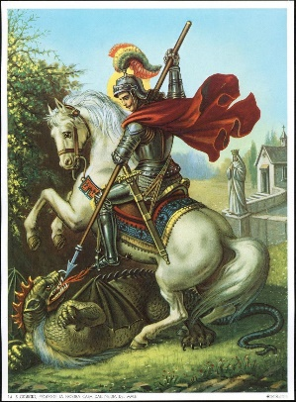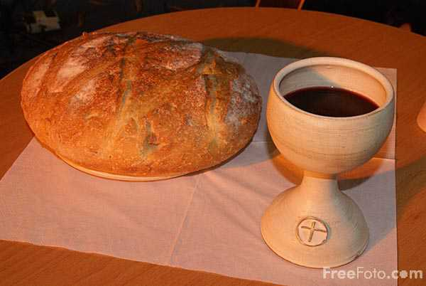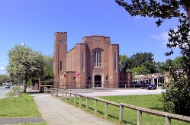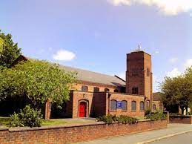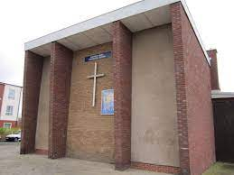

**Our Enquiry Steps:**

How are the churches in our local community similar or different?

Can you compare worship in a local church compared to one in another country?

Can you compare how communion is celebrated?

How do local Christian communities celebrate Easter?

How is Easter celebrated around the world?

How is St George remembered around the world?

**Key Artefacts and Symbols**

**Key Stories**

