KNOWLEDGE ORGANISER
How can I understand different Easter concepts?

Prior learning
- Who was Jesus and why is he important to Christians today? – Y2
Future Learning
- What are some of the differences and similarities within Christianity locally and globally? – Y6
Key Vocabulary
Resurrection | Means a 'raising up', or 'rising up' from the Greek word ANASTASIS. In the verb form it means 'to cause to stand or rise up; to raise from sleep or from the dead'. The Christian belief that God raised Jesus after his crucifixion as first of the dead, starting his exalted life as Christ and Lord. ... His resurrection is the guarantee that all the Christian dead will be resurrected at Christ's second coming.
Servanthood | Jesus was the ultimate servant during his life on earth because he willingly gave up his life for us. Christians honour his example of servanthood by humbly serving others in our daily lives.
Humility | Is an asset for self-improvement. By living a humble life, you recognize the areas of your life that need work. Proverbs 11:12 : When pride comes, then comes disgrace, but with the humble is wisdom. Clothe yourselves, all of you, with humility toward one another, for “God opposes the proud but gives grace to the humble."
Salvation | The saving of a person from sin or evil.
Lent | Lent, in the Christian tradition, is a period of about six weeks before Easter. It is a time in which Christians are supposed to be quiet and thoughtful, preparing themselves for Easter. They should pray a lot, give money to charities and give up some of the things they might otherwise do for pleasure.
Stations of the Cross | There are fourteen stations, each of which represents an event during Christ’s Passion. Walking in the footsteps of Jesus.
Sacrifice | Is a loss or something you give up, usually for the sake of a better cause. When dealing with the Hebrew Bible (Old Testament), early Judaism, and early Christianity, and their wider cultural worlds, “sacrifice” is best defined as the ritualized slaughter of animals and the processing of their bodies in relation to supernatural forces (especially gods).
Good Friday | A Christian tradition to mark the day when Jesus Christ, the son of God, was nailed to the cross. This is often known as crucification of Lord Jesus. Some believe that Good Friday evolved from God Friday, which is what the day was called initially. Some believe that the good about Good Friday is that Jesus gave up his life for his people and then came back on Easter, proving that he indeed was son of God.

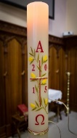
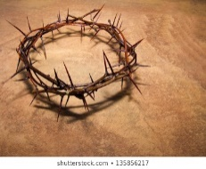
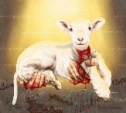
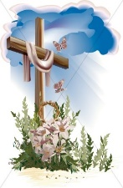
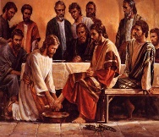
Remember Me https://www.youtube.com/watch?v=nhFBX5ZSySo
Old Rugged Cross https://www.youtube.com/watch?v=CltrLsjsQl0
When I Survey the Wonderous Cross https://www.youtube.com/watch?v=dPdmmzRHlMA
Merciful Saviour https://www.youtube.com/watch?v=915bhvKxres
Our God is Love https://www.youtube.com/watch?v=JyOdax7AhN8

Key Songs

Key Artefacts and Symbols
Hope New Life

Our Enquiry Steps:
Which of the Christian Festivals is central to the teachings of Christianity? What is sin?
What is servanthood and how is this shown through the Easter story and through the life of a Christian today?
What is the significance of the Stations of the Cross for those who are Catholic?
What does the concept of Sacrifice mean to you?
How is the concept of sacrifice shown through Christian hymns and modern songs of worship?
Can you explain different symbols associated with Easter?
Why was Jesus given a crown of thorns?

