KNOWLEDGE ORGANISER
What is the Kingdom of God and what do Christians believe about the afterlife?

Key Vocabulary
Faith | strong belief in someone or something, based on spiritual conviction rather than proof.
Values | principles or standards of behaviour; your judgement of what is important in life.
Kingdom of God | the spiritual realm over which God reigns as king.
Chairty | the voluntary giving of help, typically in the form of money, to those in need.
Compassion | sympathetic pity and concern for the sufferings or misfortunes of others.
Memories | something remembered from the past.
Eternity | infinite or unending time: endless life after death.
Heaven | a place regarded in various religions as the abode of God (or the gods) and the angels, and of the good after death, often traditionally depicted as being above the sky.

Prior learning
- What do I think about Jesus and how is he portrayed in art from around the world? – Y3
- How did Jesus teach about God and values through parables? – Y4
- How and why do Christians worship? What are the benefits to believers? – Y5
Future Learning

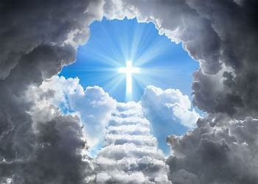
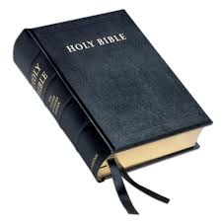
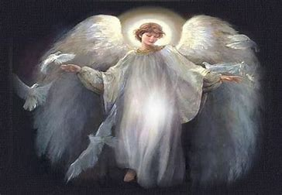
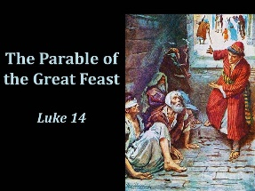
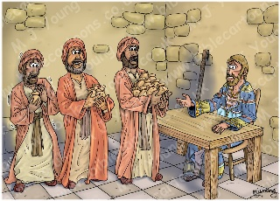
Key Artefacts and Symbols

Key Stories
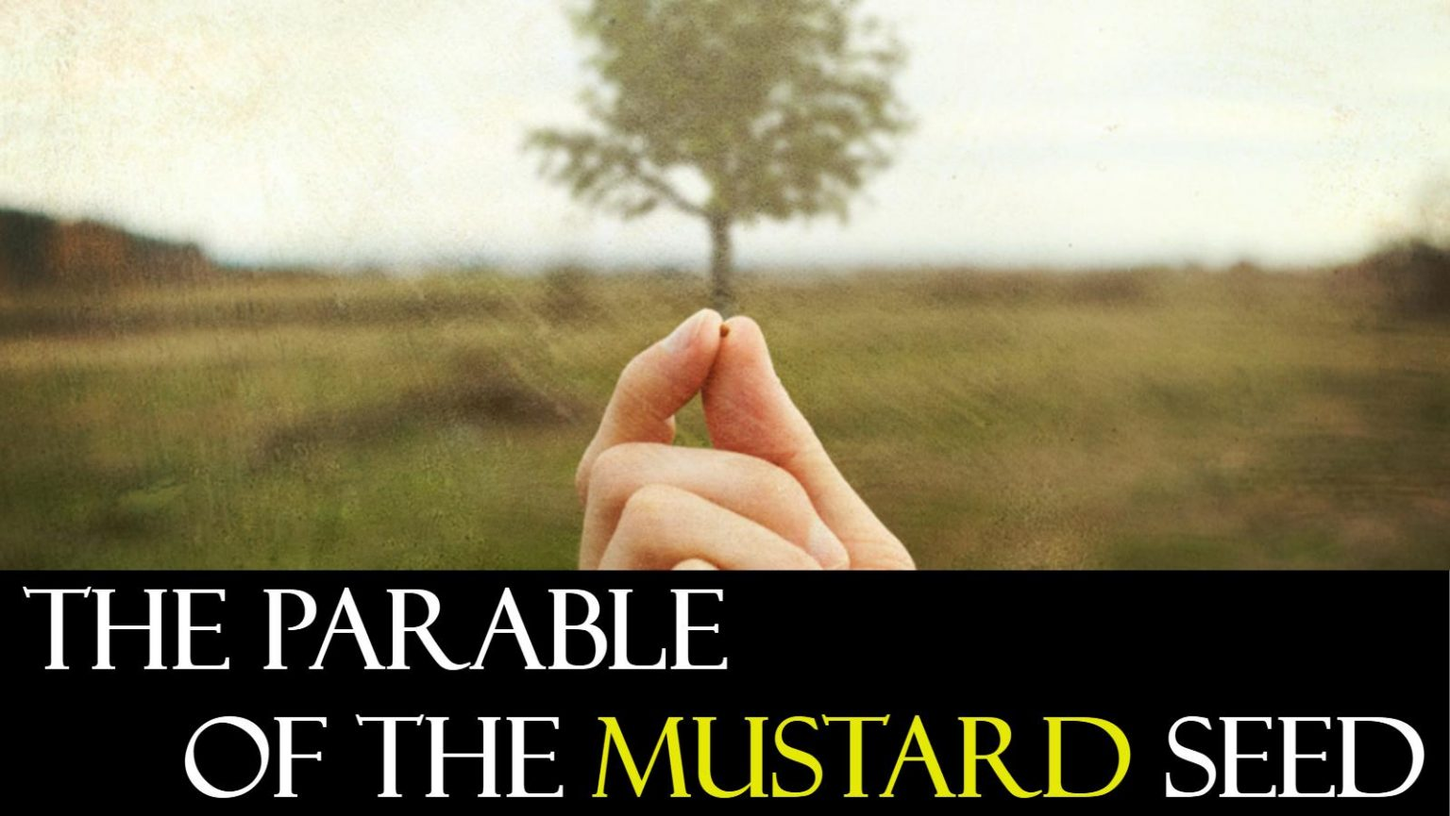

Our Enquiry Steps:
What did Jesus teach about the Kingdom of God in the Parable of the Mustard Seed?
How does Jesus use the parables of the Great Feast and the Pearl to explain the Kingdom of God?
How does the local church community live as God’s Kingdom on Earth?
How does a belief in the Kingdom of God inspire and influence Christians across the world?
What do you believe about life after death?
What do Christians believe about life after death?

