Prior learning
Future Learning
- How do Baha’is express unity through prayer and service? – Y5
KNOWLEDGE ORGANISER
What is the Baha’i Faith?

Key Vocabulary
5 Fingers | Bahaï, Bahaïs, Houses of Worship, Aqdas, Nine Sided Star
Bâb | The Bâb means ‘Gate’. He said he was the Gateway to the next religion, which would unite the world.
Baha’u’llah | The Glory of God
Bahaï | To be a Bahaï means that a person believes that Baha’u’llah is the manifestation of God for this time. A Bahaï strives to follow his teachings and observes his laws.
Unity | Being united or joined as a whole.  Bahaïs believe the world should be united. That all human beings should be like one family.
Houses of Worship | Houses of Worship are the religious place of worship. They are also known as Mashriqu’l-Adhkar.
Ridvan | Ridvan means ‘Paradise’. It is the name for the Garden of Ridvan outside Baghdâd. Baha’u’llah stayed there for twelve days.
Nine Sided Star | A symbol of perfection and unity.

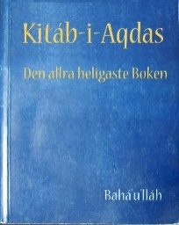
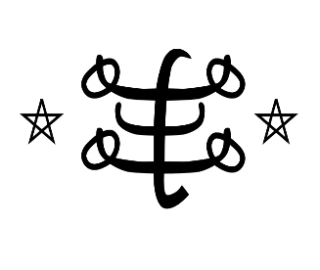
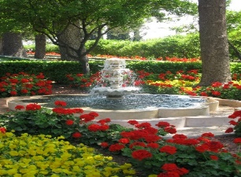
Our Enquiry Steps:
What is the Baha’i Faith?
Who was the Bab?
Who was Baha’u’llah?
Why is Unity so important in the Baha’i Faith?
How do Baha’is pray and who do they worship?
Is there a special place of worship for Baha’is?

Key Artefacts and Symbols
Baha’u’llah wrote many books and letters, and Abduu’l-Baha also wrote many books and letters which Bahaïs see as special.
Finally Baha’u’llah’s Great Grandson Shoghi Effendi wrote lots of books and letters which Baha’is use to better understand the writings of Baha’u’llah and Abdu’l-Baha. The most important of these books is the’ Aqdas’.

Key Stories

