In Year Application process.
If you wish to apply for a place for your child at Dee Point at any time, other than for a Reception September start, this is known as an In Year Application. This is done online at
https://www.cheshirewestandchester.gov.uk/residents/education-and-learning/school-admissions/school-admissions.aspx
which takes you to this screen: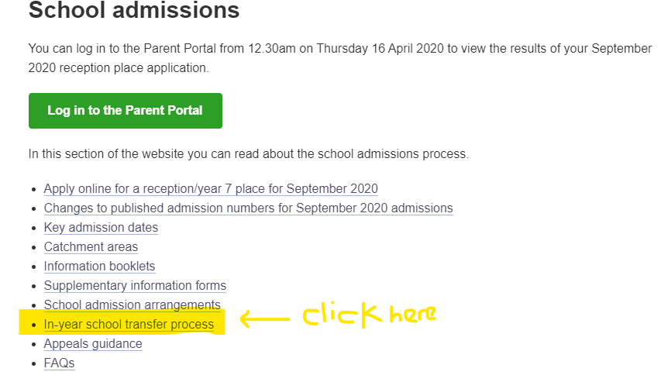
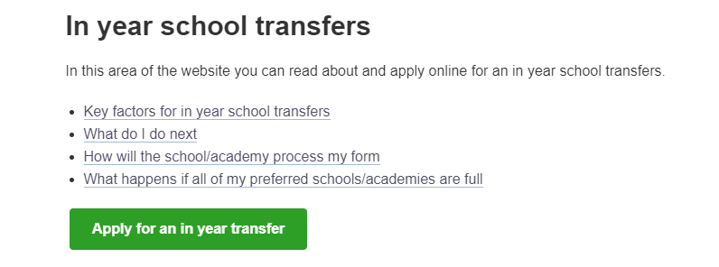
Click the green Apply for an in year transfer box.
On the following page you need to create an account- click on the circled area. Then follow instructions on screen.
