Lively Liverpool
There are many cities in England which are famous for their landmarks, sights and events. One of the most well-known is Liverpool! Do you know anything about this superb city? Read on to find out more.
Where is Liverpool?
Liverpool is a large city in the north-west of England. It is west of Manchester and is fairly close to north Wales. Similar to Chester, Liverpool is situated on a river, which is called the river Mersey. Some people think that Liverpool is difficult to get to because of the Mersey. However, there is a connection called the Kingsway tunnel, so you can pass under the water easily. In addition, there is the Queensway tunnel.
Like most big cities, Liverpool has several train stations, so this means that people can reach Liverpool from all over the United Kingdom. Not only can Liverpool be reached by rail, it can also be reached by plane because of its airport. Without a doubt this makes Liverpool an easy place to visit for anyone in Europe.
Liverpool’s Famous Landmarks:
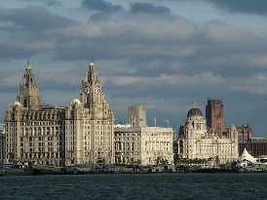
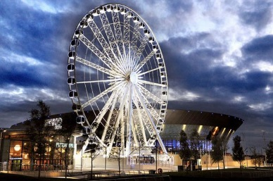
Similar to other famous cities, Liverpool is full of historical buildings, statues and monuments. Many people think that one of the most impressive landmarks is the Liver Building because of the colossal, stone carved birds which stand atop its domes and watch over the city. Like the UK’s capital of London, Liverpool also has a big wheel. The wheel, which stands next to the Echo arena, is a more modern landmark of the city.
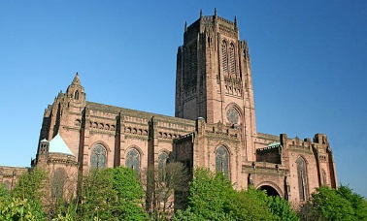
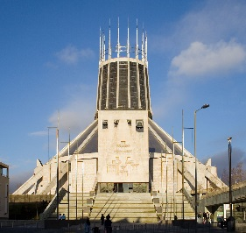
In contrast to other cities of its size, Liverpool has not one, but two cathedrals. One is the huge Anglican cathedral and the other is the newer and more modern Metropolitan cathedral. Both cathedrals have very different designs, so they are popular landmarks for visitors. Amazingly, many of Liverpool’s landmarks can even be seen from as far away as Chester!

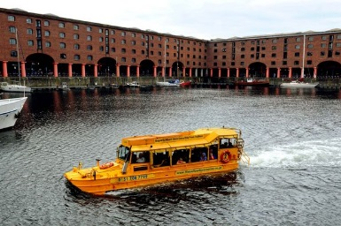
What can you do in Liverpool?
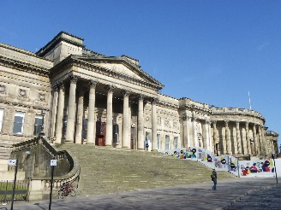
Due to its size and interesting history, there are lots of things to do in this exciting city. Many people visit the Albert Dock because of its museums and boats. Did you know you can ride a yellow ‘duck-marine’ in the water of the Albert Dock when it is summer? In addition to the museums of the docks, Liverpool also has a World Museum near the city centre. The World Museum has many exhibitions which change during the year, such as an ancient Egypt exhibition. Furthermore, Liverpool has two football clubs (called Liverpool and Everton), so many people like to watch a football match when they are visiting the city.

Did you know?
Interestingly, nobody knows how Liverpool got its name!
Now you know all about the brilliant city of Liverpool and why it is so famous. Can you find out more about the history or people of this lively, unique and diverse city?

