Maths Calculation Policy

Delegate Function: Headteacher

Approved by Governors:

Updated: Autumn 2022

Review date: Autumn 2023

Dee Point Primary School Calculation Policy

This document sets out the expectations for each year group relating to both written and mental calculation strategies. To begin with, these should be taught as stand-alone skills, and then applied to more complex mathematical problems in a range of contexts once embedded.

Concrete, Pictorial, Abstract

Children’s understanding of these calculation strategies will be underpinned by a secure understanding of place value and number. At Dee Point, we use a CPA (concrete, pictorial, abstract) approach to support the development of new concepts and skills. Conceptual variation is vital so that children can apply their understanding in a range of ways.

Manipulatives will be available in all classrooms for children to access as and when they need. After using concrete resources, methods and strategies will be further explored using pictorial techniques before moving onto more abstract questions.

Mental Strategies

At Dee Point, we recognise how important it is for mental strategies to be given priority so that children become fluent mathematicians. Specific skills will be taught discretely, as well as being embedded within reasoning lessons so that children have the ability to apply these strategies across the full curriculum.

Addition
Year 1
National Curriculum Objectives | Key Vocabulary
- read, write and interpret mathematical statements involving addition (+) and equals (=) signs  - represent and use number bond facts within 20  - add one-digit and two-digit numbers to 20, including zero  - solve one-step problems that involve addition using concrete objects and pictorial representations, and missing number problems such as 7 =? – 9. | - Addition  - Add  - More  - More than  - Makes  - Altogether  - Most  - Put together

Key Manipulatives and Images

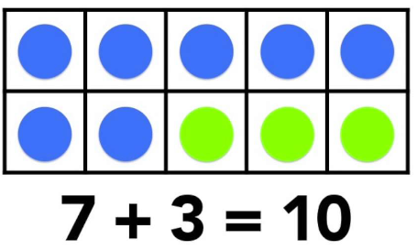

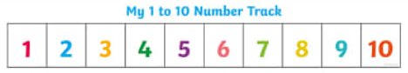

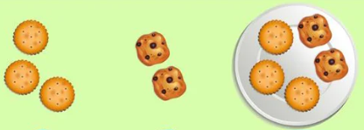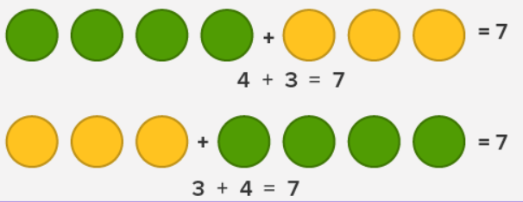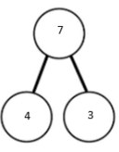

Mental Methods
Recognise commutative law
Count on from the greatest number in the calculation
Use known facts (e.g. number bonds to 10)

Written Methods
Draw separate amounts and count up the total
Count on using a number track
Use a blank number line without bridging
Use a blank number line with bridging
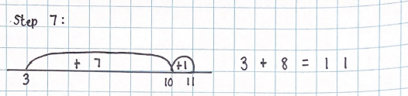
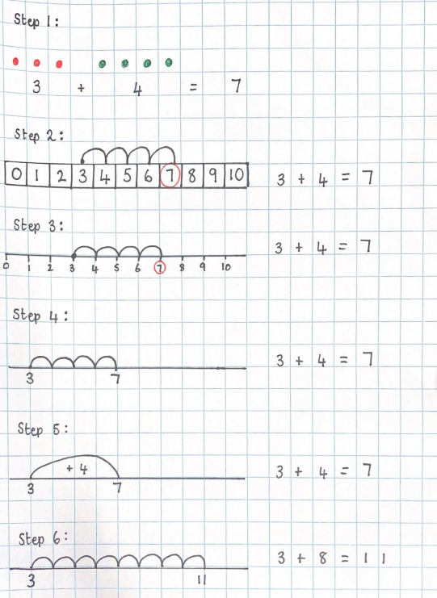

Addition
Year 2
National Curriculum Objectives | Key Vocabulary
1. solve problems with addition  - using concrete objects and pictorial representations, including those involving numbers, quantities and measures  - applying their increasing knowledge of mental and written methods  2. recall and use addition facts to 20 fluently, and derive and use related facts up to 100  3. add numbers using concrete objects, pictorial representations, and mentally, including:  - a two-digit number and ones  - a two-digit number and tens  - two two-digit numbers  4. adding three one-digit numbers  5. show that addition of two numbers can be done in any order (commutative)  6. recognise and use the inverse relationship between addition and subtraction and use this to check calculations and solve missing number problems. | - Addition  - Add  - More  - More than  - Makes  - Altogether  - Most  - Put together  - Total  - Double

Key Manipulatives and Images

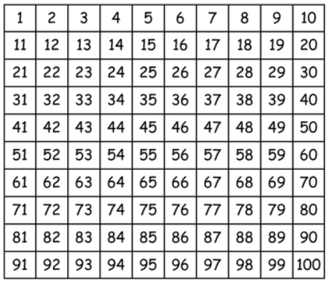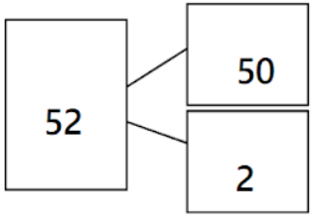
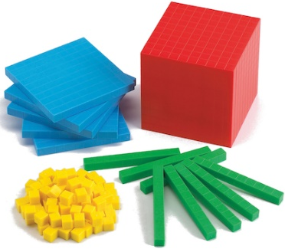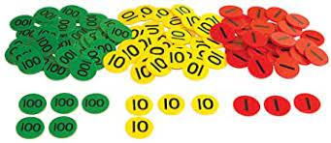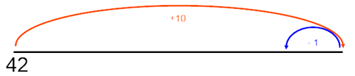

Mental Methods
Recognise commutative law
Use known facts (e.g. number bonds to 10 and 20)
Add ones to a 2-digit number
Add tens to a 2-digit number
Add multiples of ten to a 2-digit number
Compliments to 100
Add ones to a 2-digit number with bridging using partitioning (e.g. 47 + 9 = 47 + 3 + 6)
Add tens to a 2-digit number with bridging using partitioning (e.g. 80 + 40 = 80 + 20 +20)
Add 9 to a number by adding 10 and subtracting 1
Add 99 to a number by adding 100 and subtracting 1

Written Methods
TO + TO using a blank number line with partitioning (individual jumps of ten)
TO + TO using a blank number line with partitioning (chunking tens)
TO + TO using partitioning into tens and ones (investigate commutativity)
Repeat above but with questions that involve bridging
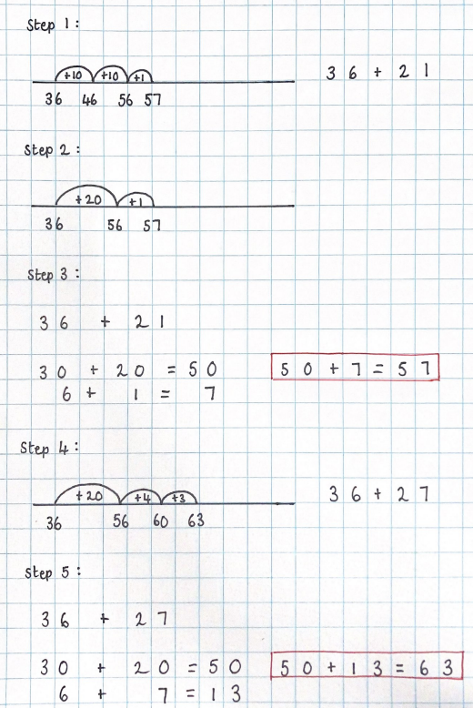

Addition
Year 3
National Curriculum Objectives | Key Vocabulary
- add numbers mentally, including:  - a three-digit number and ones  - a three-digit number and tens  - a three-digit number and hundreds  - estimate the answer to a calculation and use inverse operations to check answers  - solve problems, including missing number problems, using number facts, place value, and more complex addition  NO FORMAL WRITTEN METHOD FOR ADDITION | - Addition  - Add  - More  - More than  - Makes  - Altogether  - Most  - Put together  - Total  - Double  - Partitioning  - Commutativity  - Redistribution

Key Manipulatives and Images

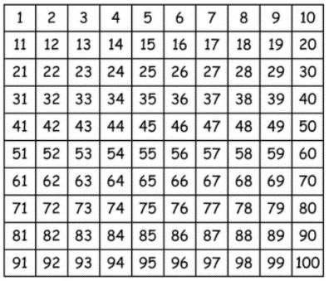
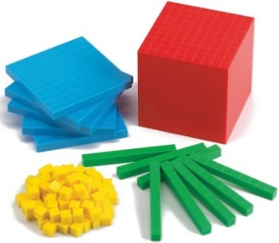

Mental Methods
Recognise commutative law
Use known facts (e.g. number bonds to 10, 20 and 100)
Add two 1-digit numbers using near doubles that bridge (e.g. 6 + 7 = 6 + 6 + 1 or 7 + 7 – 1)
HTO + O without bridging
HTO + T without bridging
HTO + H without bridging
HTO + TO without bridging
HTO + HTO without bridging
Add near multiples of 10 by adding the multiple of 10 and subtracting 1 (35 + 59 = 35 + 60 – 1)
Add near multiples of 100 by adding the multiple of 100 and subtracting 1 (135 + 199 = 135 + 200 – 1)
HTO + O with bridging using redistribution
HTO + TO with bridging using redistribution
HTO + HTO with bridging using redistribution

Addition
Year 4
National Curriculum Objectives | Key Vocabulary
1. add 4 numbers mentally, including:  - a four-digit number and ones  - a four-digit number and tens  - a four-digit number and hundreds  - a four-digit number and thousands  2. estimate and use inverse operations to check answers to a calculation  3. solve addition two-step problems in contexts, deciding which operations and methods to use and why.  NO FORMAL WRITTEN METHOD FOR ADDITION | - Addition  - Add  - More  - More than  - Makes  - Altogether  - Most  - Put together  - Total  - Double  - Partitioning  - Commutativity  - Redistribution  - Tenths  - Hundredths  - Decimal point

Key Manipulatives and Images

Mental Methods
Recognise commutative law
Use known facts (e.g. number bonds to 10, 20 and 100, 1000 and 1)
Add two 2-digit numbers using near doubles that bridge (e.g. 36 + 37 = 36 + 36 + 1 or 37 + 37 – 1)
ThHTO + O without bridging
ThHTO + T without bridging
ThHTO + H without bridging
ThHTO + Th without bridging
ThHTO + ThHTO without bridging
Add near multiples of 10 by adding the multiple of 10 and subtracting 1 (235 + 259 = 235 + 260 – 1)
Add near multiples of 100 by adding the multiple of 100 and subtracting 1 (2135 + 199 = 2135 + 200 – 1)
ThHTO + O with bridging using redistribution
ThHTO + T with bridging using redistribution
ThHTO + H with bridging using redistribution
Redistribution variety
ThHTO + ThHTO using partitioning into PV columns

Addition
Year 5
National Curriculum Objectives | Key Vocabulary
- add whole numbers with 3 or more digits, including using formal written methods (columnar addition)  - add numbers mentally with increasingly large numbers  - use rounding to check answers to calculations and determine, in the context of a problem, levels of accuracy solve addition multi-steps problems in contexts, deciding which operations and methods to use and why. | - Addition  - Add  - More  - More than  - Makes  - Altogether  - Most  - Put together  - Total  - Double  - Partitioning  - Commutativity  - Redistribution  - Tenths  - Hundredths  - Decimal point

Key Manipulatives and Images

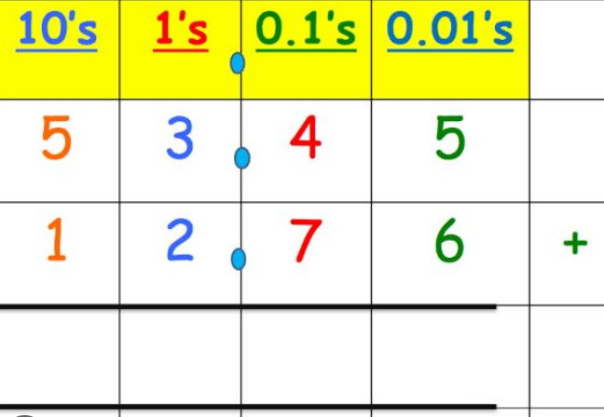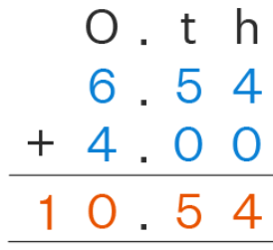

Mental Methods
Recap and regular practise of previously taught mental strategies from year 3 and 4 including:
Adding near doubles
Partitioning
Adding near multiples of 10, 100, 1000
Redistribution
Application of above to money
Written Methods
ThHTO + ThHTO in a column method without bridging
Manipulate the above with a range of PV
ThHTO + ThHTO in a column method with bridging of ones
ThHTO + ThHTO in a column method with bridging of tens
ThHTO + ThHTO in a column method with bridging of hundreds
ThHTO + ThHTO in a column method with bridging of thousands
Manipulate all of the above with a range of PV
Adding 3 or more numbers using a column method to emphasise that we don’t always regroup 1
Column method using decimals (same PV)
Column method using decimals (mixed PV)
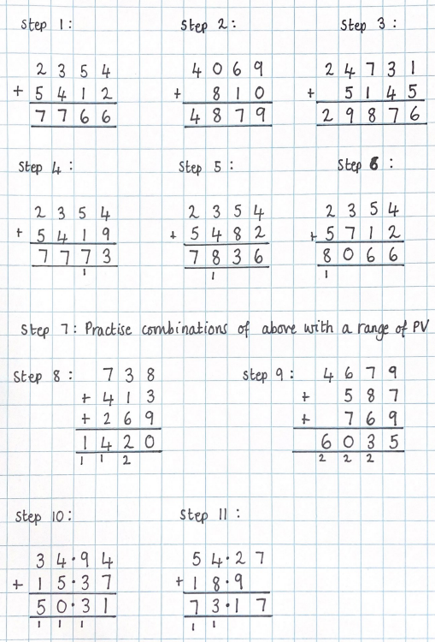

Addition
Year 6
National Curriculum Objectives | Key Vocabulary
- add whole numbers with 3 or more digits, including using formal written methods (columnar addition)  - add numbers mentally with increasingly large numbers  - use rounding to check answers to calculations and determine, in the context of a problem, levels of accuracy solve addition multi-steps problems in contexts, deciding which operations and methods to use and why. | - Addition  - Add  - More  - More than  - Makes  - Altogether  - Most  - Put together  - Total  - Double  - Partitioning  - Commutativity  - Redistribution  - Tenths  - Hundredths  - Decimal point

Key Manipulatives and Images

Mental Methods
Recap and regular practise of previously taught mental strategies from year 3 and 4 including:
Adding near doubles
Partitioning
Adding near multiples of 10, 100, 1000
Redistribution
Application of above to money and measures

Written Methods
Use column method to add whole numbers with different PV
Use column method to add decimal numbers with different PV
Adding 3 or more numbers using a column method to emphasise that we don’t always regroup 1
Adding positive numbers to a negative number using a blank number line (vertical and horizontal)

Subtraction
Year 1
National Curriculum Objectives | Key Vocabulary
- read, write and interpret mathematical statements involving subtraction (-) and equals (=) signs  - represent and use number bond facts within 20  - subtract one-digit and two-digit numbers to 20, including zero  - solve one-step problems that involve subtraction using concrete objects and pictorial representations, and missing number problems such as 7 =? – 9. | - Subtraction  - Subtract  - Take Away  - Less  - Less than  - Least

Key Manipulatives and Images

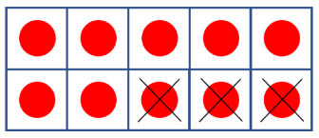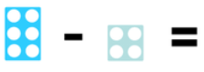

Mental Methods
Recognise commutative law can’t be done when subtracting
Count back 1 from a starting number
Count back from the greatest number in the calculation
Subtract ones from ones
Use known facts (e.g. number bonds to 10)

Written Methods
Cross out specified number from a group of objects (various pictorial representations)
Count back using a number track
Use a blank number line without bridging
Use a blank number line with bridging
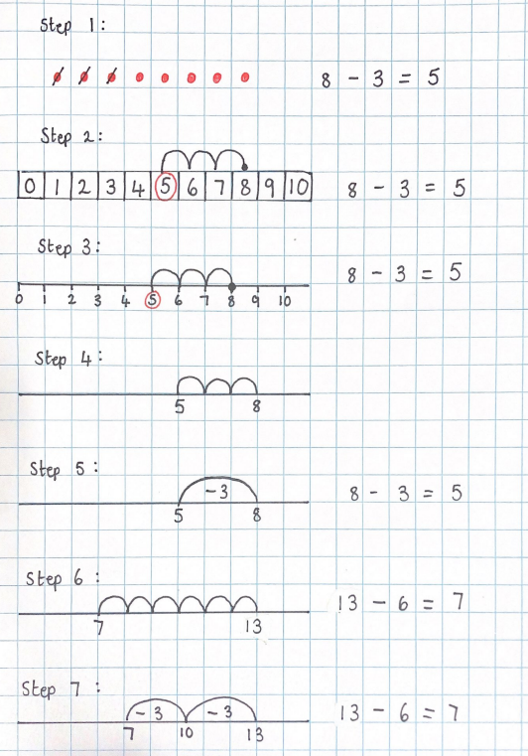

Subtraction
Year 2
National Curriculum Objectives | Key Vocabulary
1. solve problems with subtraction  - using concrete objects and pictorial representations, including those involving numbers, quantities and measures  - applying their increasing knowledge of mental and written methods  2. recall and use subtraction facts to 20 fluently, and derive and use related facts up to 100  3. subtract numbers using concrete objects, pictorial representations, and mentally, including:  - a two-digit number and ones  - a two-digit number and tens  - two two-digit numbers  4. subtracting three one-digit numbers  5. show that subtraction of two numbers cannot be done in any order (commutative)  6. recognise and use the inverse relationship between addition and subtraction and use this to check calculations and solve missing number problems. | - Subtraction  - Subtract  - Take away  - Difference/Difference between  - Less  - Less than  - Left  - Least  - Half  - Double

Key Manipulatives and Images

Mental Methods
Recognise commutative law doesn’t work for subtraction
Use known facts (e.g. number bonds to 10 and 20)
Subtract ones from a 2-digit number
Subtract tens from a 2-digit number
Subtract multiples of ten from a 2-digit number
Use inverse and knowledge of compliments to 100
Subtract ones from a 2-digit number with bridging using partitioning (e.g. 43 - 6 = 43 - 3 - 3)
Subtract tens from a 2-digit number with bridging using partitioning (e.g. 120 - 40 = 120 - 20 - 20)
Subtract 9 to a number by subtracting 10 and adding 1
Subtract 99 to a number by subtracting 100 and adding 1

Written Methods
TO - TO using a blank number line with partitioning (individual jumps of ten)
TO - TO using a blank number line with partitioning (chunking tens)
TO - TO using partitioning into tens and ones (investigate commutativity)
Repeat above but with questions that involve bridging
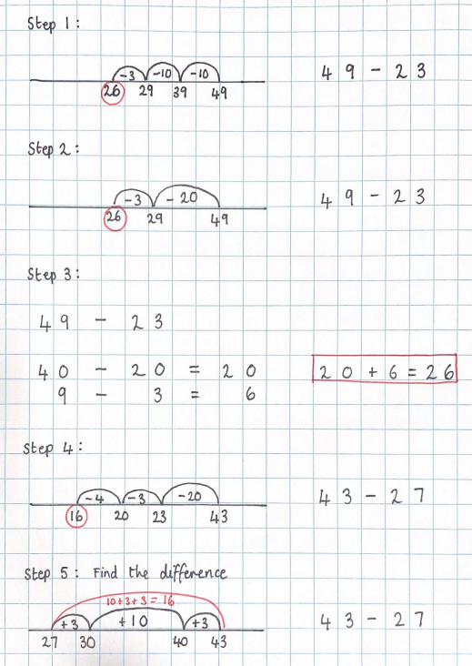

Subtraction
Year 3
National Curriculum Objectives | Key Vocabulary
- subtract numbers mentally, including:  - a three-digit number and ones  - a three-digit number and tens  - a three-digit number and hundreds  - estimate the answer to a calculation and use inverse operations to check answers  - solve problems, including missing number problems, using number facts, place value, and more complex subtraction  NO FORMAL WRITTEN METHOD FOR ADDITION | - Subtraction  - Subtract  - Take Away  - Difference/Difference between  - Minus  - Less  - Less than  - Left  - Half  - Partitioning  - Redistribution

Key Manipulatives and Images

Mental Methods
Recognise subtraction doesn’t follow the commutative law
Use known facts (e.g. number bonds to 10, 20 and 100)
HTO - O without bridging
HTO - T without bridging
HTO - H without bridging
HTO - TO without bridging
HTO - HTO without bridging
Subtract near multiples of 10 by subtracting the multiple of 10 and adding 1 (86 - 49 = 86 - 50 + 1)
Subtract near multiples of 100 by subtracting the multiple of 100 and adding 1 (387 + 199 = 387 - 200 + 1)
HTO - O with bridging using redistribution
HTO - TO with bridging using redistribution
HTO - HTO with bridging using redistribution
Subtraction
Year 4
National Curriculum Objectives | Key Vocabulary
1. subtract 4 numbers mentally, including:  - a four-digit number and ones  - a four-digit number and tens  - a four-digit number and hundreds  - a four-digit number and thousands  2. estimate and use inverse operations to check answers to a calculation  3. solve subtraction two-step problems in contexts, deciding which operations and methods to use and why.  NO FORMAL WRITTEN METHOD FOR ADDITION | - Subtraction  - Subtract  - Take Away  - Difference/Difference between  - Minus  - Less  - Less than  - Left  - Half  - Partitioning  - Redistribution  - Tenths  - Hundredths  - Decimal point

Key Manipulatives and Images

Mental Methods
Recognise subtraction doesn’t follow the commutative law
Use known facts (e.g. number bonds to 10, 20 and 100, 1000 and 1)
ThHTO - O without bridging
ThHTO - T without bridging
ThHTO - H without bridging
ThHTO - Th without bridging
ThHTO - ThHTO without bridging
Subtract near multiples of 10 by subtracting the multiple of 10 and adding 1 (249 - 129 = 249 - 130 + 1)
Subtract near multiples of 100 by subtracting the multiple of 100 and adding 1
(2435 - 399 = 2435 - 400 + 1)
ThHTO - O with bridging using redistribution
ThHTO - T with bridging using redistribution
ThHTO - H with bridging using redistribution
Redistribution variety
ThHTO - ThHTO using partitioning into PV columns

Subtraction
Year 5
National Curriculum Objectives | Key Vocabulary
- subtract whole numbers with 3 or more digits, including using formal written methods (columnar subtraction)  - subtract numbers mentally with increasingly large numbers  - use rounding to check answers to calculations and determine, in the context of a problem, levels of accuracy solve subtraction multi-steps problems in contexts, deciding which operations and methods to use and why. | - Subtraction  - Subtract  - Take Away  - Difference/Difference between  - Minus  - Less  - Less than  - Left  - Half  - Partitioning  - Redistribution  - Tenths  - Hundredths  - Decimal point

Key Manipulatives and Images

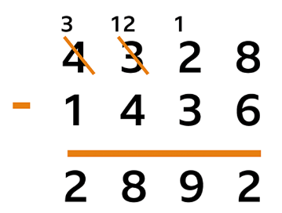

Mental Methods
Recap and regular practise of previously taught mental strategies from year 3 and 4 including:
Partitioning
Subtracting near multiples of 10, 100, 1000
Redistribution
Application of above to money

Written Methods
ThHTO - ThHTO in a column method without bridging
Manipulate the above with a range of PV
ThHTO - ThHTO in a column method with bridging of ones
ThHTO - ThHTO in a column method with bridging of tens
ThHTO - ThHTO in a column method with bridging of hundreds
ThHTO - ThHTO in a column method with bridging of thousands
Manipulate all of the above with a range of PV
Column method using decimals (same PV)
Column method using decimals (mixed PV)
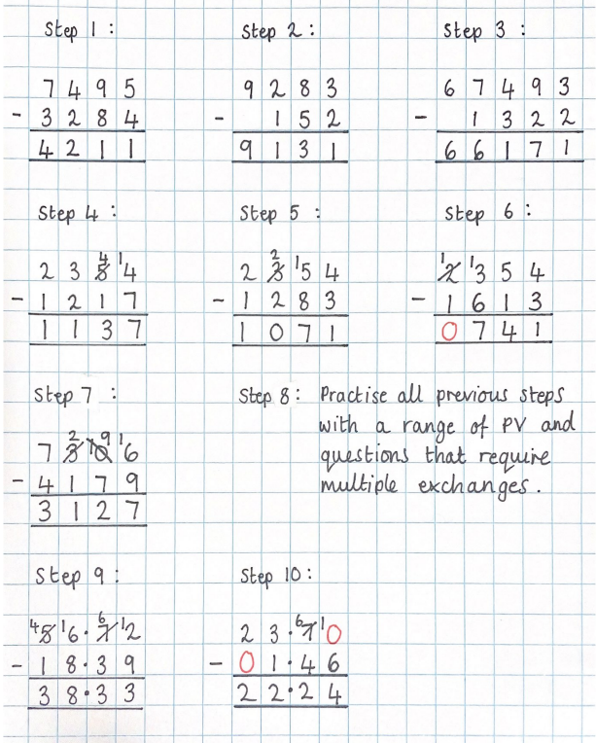

Subtraction
Year 6
National Curriculum Objectives | Key Vocabulary
- solve subtraction multi-step problems in contexts, deciding which operations and methods to use and why  - solve problems involving subtraction.  - use estimation to check answers to calculations and determine, in the context of a problem, an appropriate degree of accuracy  - perform mental calculations, including with mixed operations and large numbers  - use their knowledge of the order of operations to carry out calculations involving the four operations | - Subtraction  - Subtract  - Take Away  - Difference/Difference between  - Minus  - Less  - Less than  - Left  - Half  - Partitioning  - Redistribution  - Tenths  - Hundredths  - Decimal point
*
Key Manipulatives and Images

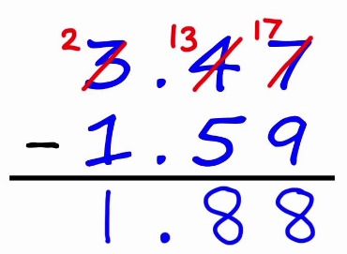

Mental Methods
Recap and regular practise of previously taught mental strategies from year 3 and 4 including:
Partitioning
Subtracting near multiples of 10, 100, 1000
Redistribution
Application of above to money and measures

Written Methods
Use column method to subtract whole numbers with different PV
Use column method to subtract decimal numbers with different PV
Subtract positive numbers from a negative number using a blank number line (vertical and horizontal)
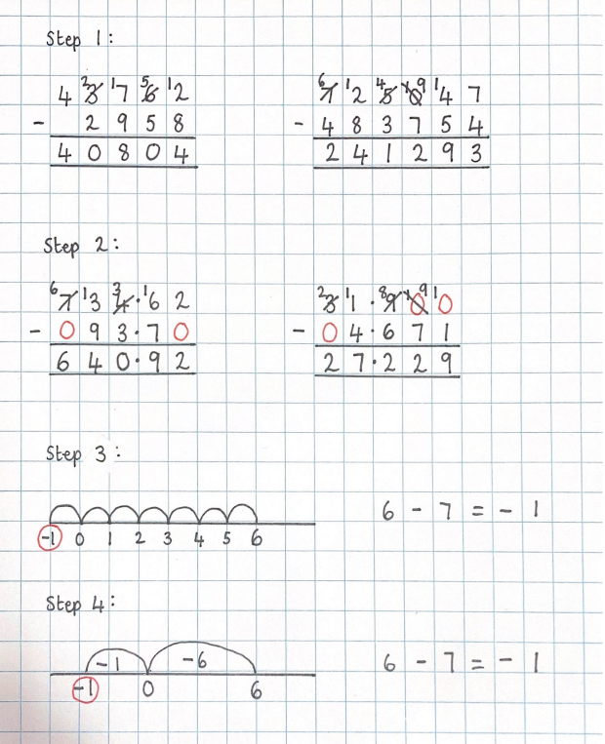
Multiplication
Year 1
National Curriculum Objectives | Key Vocabulary
1. recall and use multiplication facts for the 2, 5 and 10 multiplication tables, including recognising odd and even numbers.  2. solve one-step problems involving multiplication by calculating the answer using concrete objects, pictorial representations and arrays with the support of the teacher. | - Groups of  - Jumps of  - Skip Counting  - Altogether  - Repeated Addition  - Times  - Double

Key Manipulatives and Images

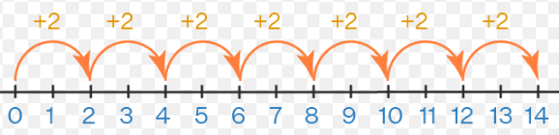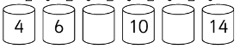
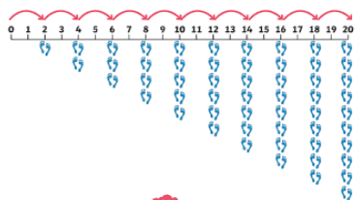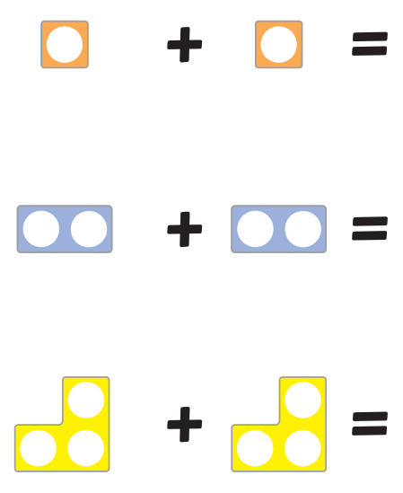

Mental Methods
Skip count in 10s
Count in 10s
Skip count in 5s
Count in 5s
Skip count in 2s
Count in 2s
Recognise the commutative law
Double digits that don’t bridge

Written Methods
Count in 2s, 5s and 10s on a number track
Count in 2s, 5s and 10s and a numbered number line
Count in 2s, 5s and 10s on an empty number line (with steps given)
Count in 2s, 5s and 10s on an empty number line

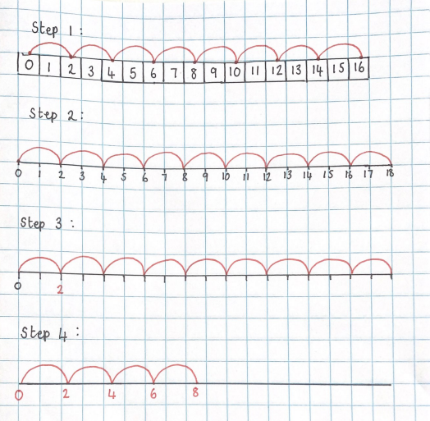

Multiplication
Year 2
National Curriculum Objectives | Key Vocabulary
- solve one-step problems involving multiplication by calculating the answer using concrete objects, pictorial representations and arrays  - calculate mathematical statements for multiplication within the multiplication tables and write them using the multiplication (×) and equals (=) signs  - show that multiplication of two numbers can be done in any order (commutative)  - solve problems involving multiplication using materials, arrays, repeated addition, mental methods, and multiplication and division facts, including problems in contexts | - Groups of  - Jumps of  - Skip Counting  - Altogether  - Repeated Addition  - Times  - Double  - Commutative Law  - Reorder  - Equal/unequal  - Number of groups  - Group size  - Array  - Number of rows  - Number of columns

Key Manipulatives and Images

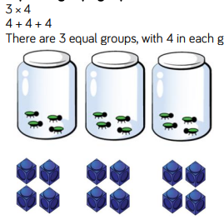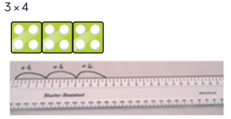
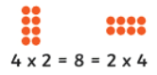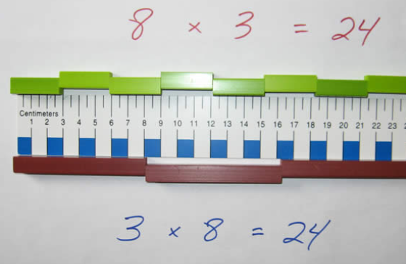
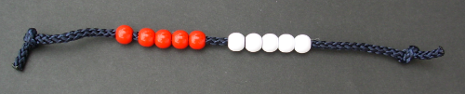

Mental Methods
Recognise the commutative law
Recall 10s from number sentence flashcards
Recall 5s from number sentence flashcards
Recall 2s from number sentence flashcards
Double TO digits that don’t bridge
Double O digits that bridge
Double TO digits that bridge

Written Methods
Count in 2s, 5s and 10s on a numbered number line
Count in 2s, 5s and 10s on an empty number line (with steps given)
Count in 2s, 5s and 10s on an empty number line
Show multiplication questions as repeated addition 3 x 5 = 5 + 5 + 5
Represent O x O multiplication questions as arrays
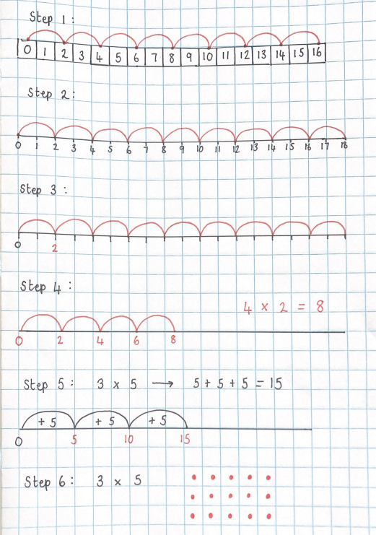

Multiplication
Year 3
National Curriculum Objectives | Key Vocabulary
- recall and use multiplication facts for the 3, 6, 4, 8, 11 multiplication tables  - write and calculate mathematical statements for multiplication using the multiplication tables that they know, including for two-digit numbers times one-digit numbers, using mental and informal written methods (e.g. partitioning/chunking)  - solve problems, including missing number problems, involving multiplication including positive integer scaling problems and correspondence problems in which n objects are connected to m objects.  NO FORMAL WRITTEN METHOD FOR MULTIPLICATION | - Groups of  - Jumps of  - Skip Counting  - Altogether  - Repeated Addition  - Times  - Commutative Law  - Reorder  - Equal/unequal  - Number of groups  - Group size  - Factor  - Factor Size  - Product  - Array  - Number of rows  - Number of columns  - Multiples

Key Manipulatives and Images
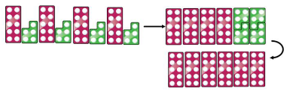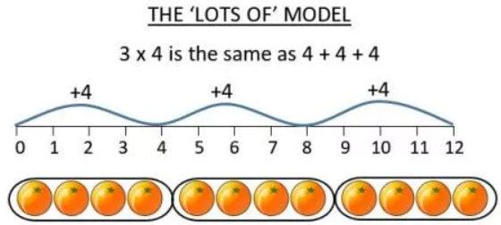

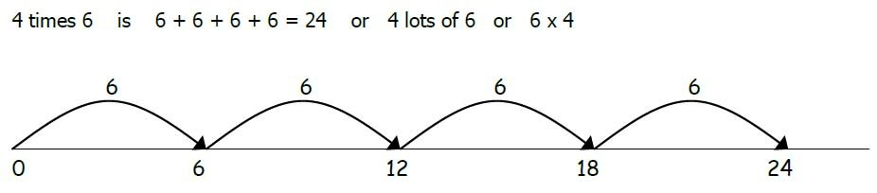

Mental Methods
Recognise the commutative law
Recall 11s from number sentence flashcards
Recall 3s from number sentence flashcards
Recall 6s from number sentence flashcards
Recall 4s from number sentence flashcards
Recall 8s from number sentence flashcards
Link times table facts (fact families) for the 11s, 3s, 6s, 4s, 8s (3x4 = 12 so 30x4 = 120 and 40x3 = 120)

Written Methods
Count in 11s, 3s, 6s, 4s and 8s on a numbered number line or hundred square
Show multiplication questions as repeated addition 3 x 5 = 5 + 5 + 5
Represent O x O multiplication questions as arrays
Represent TO x O multiplication questions as an array
TO x O using partitioning
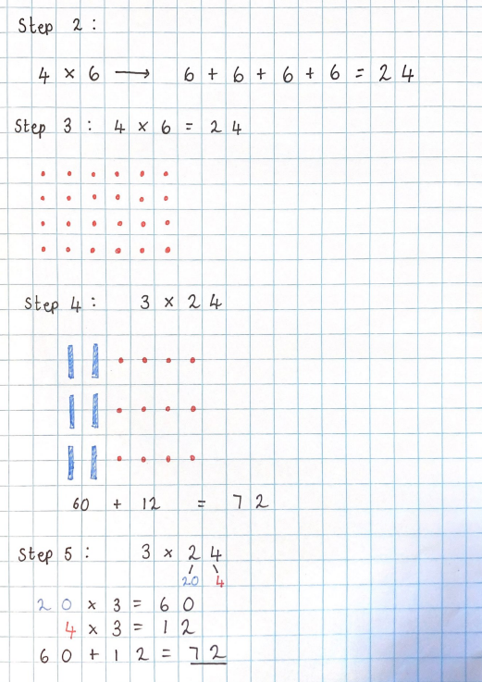

Multiplication
Year 4
National Curriculum Objectives | Key Vocabulary
- recall multiplication facts for multiplication tables up to 12 × 12  - use place value, known and derived facts to multiply mentally, including: multiplying by 0 and 1; dividing by 1; multiplying together three numbers  - recognise and use factor pairs and commutativity in mental calculations  - multiply two-digit and three-digit numbers by a one-digit number using mental and informal written methods  - solve problems involving multiplying and adding, including using the distributive law to multiply two digit numbers by one digit, integer scaling problems and harder correspondence problems such as n objects are connected to m objects.  NO FORMAL WRITTEN METHOD FOR MULTIPLICATION | - Skip Counting  - Altogether  - Repeated Addition  - Times  - Multiply  - Commutative Law  - Reorder  - Number of groups  - Group size  - Factor  - Factor Size  - Product  - Array  - Number of rows  - Number of columns  - Multiples  - Total  - Altogether  - Distributive Law

Key Manipulatives and Images

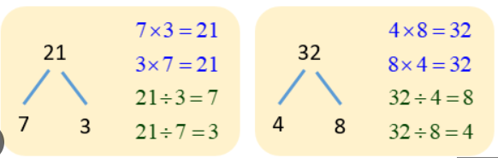
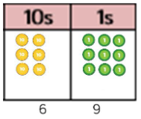

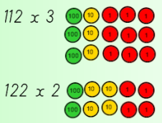

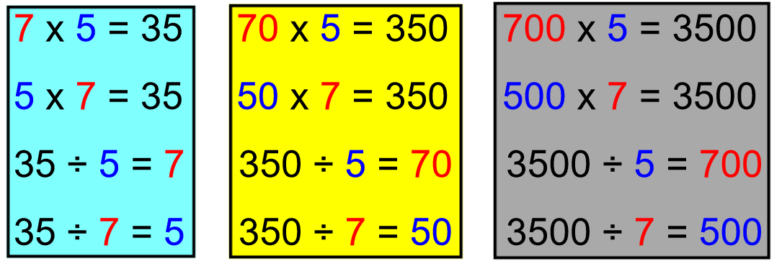

Mental Methods
Recognise the commutative law
Recall 9s from number sentence flashcards
Recall 7s from number sentence flashcards
Recall 12s from number sentence flashcards
Link times table facts (fact families) for the 9s, 7s, 12 (3x9 = 27 so 30x9 = 270 and 90x3 = 270)
Recall 1s
Recall 0s

Written Methods
Count in 9s, 7s on a numbered number line or hundred square
Show multiplication questions as repeated addition 3 x 5 = 5 + 5 + 5
Represent O x O multiplication questions as arrays
Represent TO x O multiplication questions as an array
TO x O using partitioning
Represent HTO x O multiplication questions as an array
HTO x O using partitioning

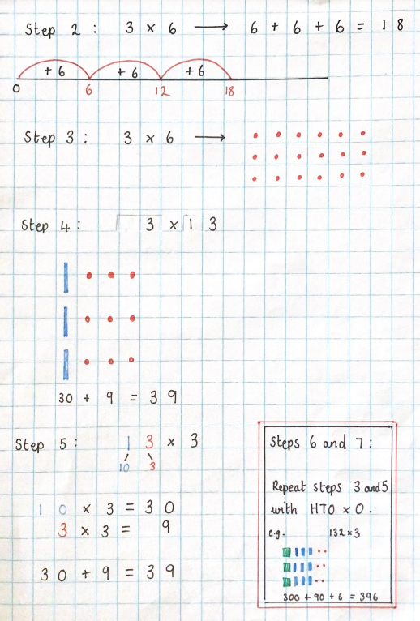

Multiplication
Year 5
National Curriculum Objectives | Key Vocabulary
- identify multiples and factors, including finding all factor pairs of a number, and common factors of two numbers know and use the vocabulary of prime numbers, prime factors and composite (nonprime) numbers  - establish whether a number up to 100 is prime and recall prime numbers up to 19  - multiply numbers up to 4 digits by a one- or two-digit number using a formal written method, including long multiplication for two-digit numbers  - multiply numbers mentally drawing upon known facts  - multiply whole numbers and those involving decimals by 10, 100 and 1000  - recognise and use square numbers and cube numbers, and the notation for squared ( 2 ) and cubed (3 )  - solve problems involving multiplication including using their knowledge of factors and multiples, squares and cubes  - solve problems involving addition, subtraction, multiplication and division and a combination of these, including understanding the meaning of the equals sign  - solve problems including scaling by simple fractions and problems involving simple rates | - Altogether  - Repeated Addition  - Times  - Multiply  - Commutative Law  - Reorder  - Number of groups  - Group size  - Factor  - Factor Size  - Product  - Number of rows  - Number of columns  - Multiples  - Total  - Altogether  - Distributive Law  - Prime Numbers  - Square Numbers  - Cube Numbers  - Volume

Key Manipulatives and Images

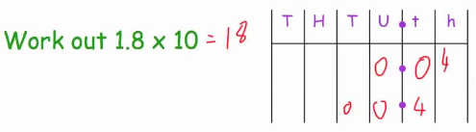

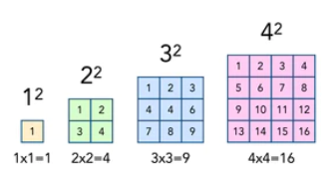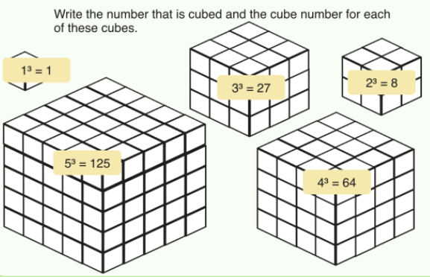

Mental Methods
Recognise the commutative law
Recall all multiplication tables from flashcards
Link times table facts (fact families) for all tables
Link times table facts (fact families) for all tables with a focus on decimal links
Multiply whole numbers by 10, 100, 1000
Multiply decimals numbers by 10, 100, 1000

Written Methods
Revisit TO x O using partitioning
Revisit HTU x O using partitioning
ThHTU x 0 using partitioning
HTO x O using the grid
TO x TO using the grid
HTO x TO using the grid
TO x TO using the expanded column method
HTO x TO using the expanded column method
TO x TO using the column method
HTO x TO using the column method

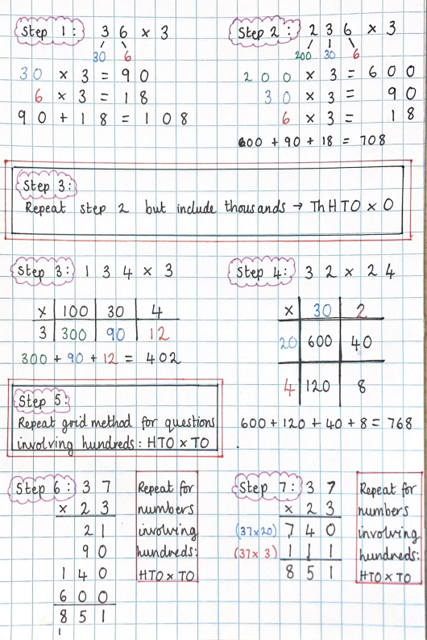

Multiplication
Year 6
National Curriculum Objectives | Key Vocabulary
- multiply multi-digit numbers up to 4 digits by a two-digit whole number using the formal written method of long multiplication  - divide numbers up to 4 digits by a two-digit whole number using the formal written method of long division, and interpret remainders as whole number remainders, fractions, or by rounding, as appropriate for the context  - divide numbers up to 4 digits by a two-digit number using the formal written method of short division where appropriate, interpreting remainders according to the context  - identify common factors, common multiples and prime numbers  - solve problems involving addition, subtraction, multiplication and division  - use estimation to check answers to calculations and determine, in the context of a problem, an appropriate degree of accuracy  - perform mental calculations, including with mixed operations and large numbers  - use their knowledge of the order of operations to carry out calculations involving the four operations | - Altogether  - Repeated Addition  - Times  - Multiply  - Commutative Law  - Reorder  - Number of groups  - Group size  - Factor  - Factor Size  - Product  - Number of rows  - Number of columns  - Multiples  - Total  - Altogether  - Distributive Law  - Prime Numbers  - Square Numbers  - Cube Numbers  - Volume  - Ratio  - Scale Factors  - Proportion

Key Manipulatives and Images

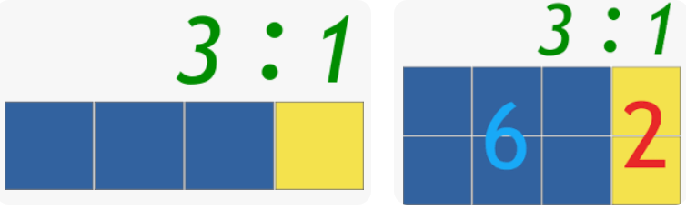

Mental Methods
Recognise the commutative law
Recap and regular practise of previously taught mental strategies from year 5 including.
Link times table facts (fact families) for all tables
Link times table facts (fact families) for all tables with a focus on decimal links
Multiply decimals 1dp by single digit whole numbers
Multiply whole numbers by 10, 100, 1000
Multiply decimals numbers by 10, 100, 1000

Written Methods
Revisit Year 5 multiplication skills
Multiply whole numbers by whole numbers using the column method
Multiply decimals by whole numbers using the grid method
Multiply decimals by whole numbers using the column method
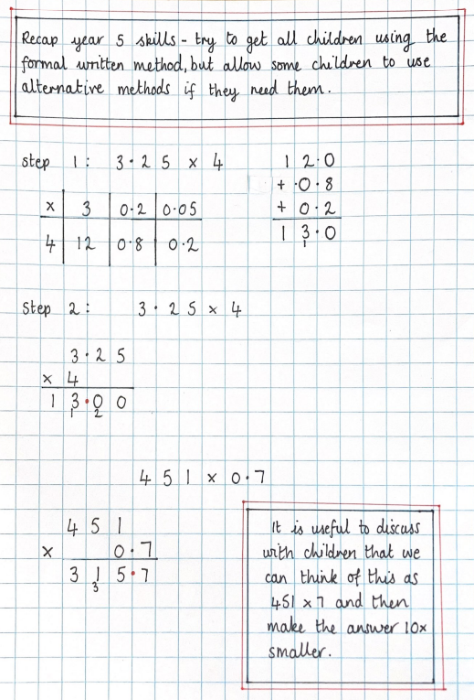

Division
Year 1
National Curriculum Objectives | Key Vocabulary
- recall and use division facts for the 2, 5 and 10 multiplication tables, including recognising odd and even numbers  - solve one-step problems involving division, by calculating the answer using concrete objects, pictorial representations and arrays with the support of the teacher. | - Skip Counting  - Repeated Subtraction  - Divide  - Share  - Halving

Key Manipulatives and Images

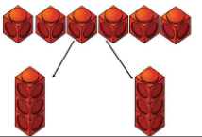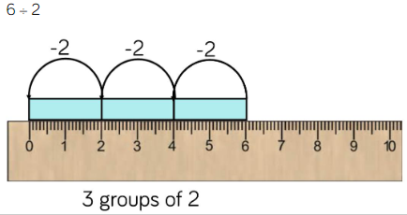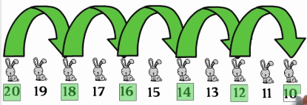

Mental Methods
Count back in 10s
Count back in 5s
Count back in 2s

Written Methods
Count back 2s, 5s and 10s on a number track
Count back 2s, 5s and 10s and a numbered number line
Count back 2s, 5s and 10s on an empty number line (with steps given)
Count back 2s, 5s and 10s on an empty number line

Division
Year 2
National Curriculum Objectives | Key Vocabulary
- solve one-step problems involving division, by calculating the answer using concrete objects, pictorial representations and arrays with the support of the teacher.  - calculate mathematical statements for division within the multiplication tables and write them using division (÷) and equals (=) signs  - show that division of two numbers cannot be done in any order (commutative)  - solve problems involving division, using materials, arrays, repeated subtraction, mental methods, division facts, including problems in contexts | - Skip Counting  - Repeated Subtraction  - Divide  - Share  - Halving  - Equal  - Unequal  - Remainder  - Left Over

Key Manipulatives and Images

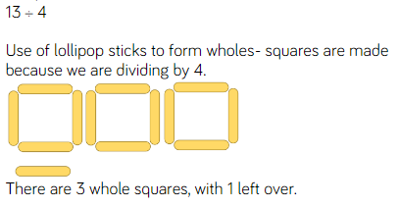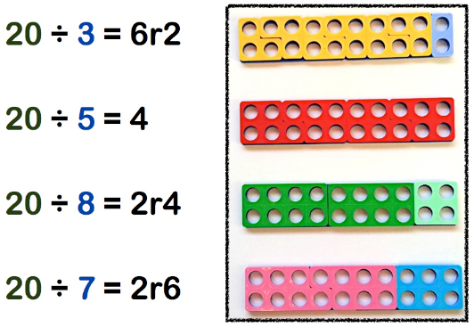
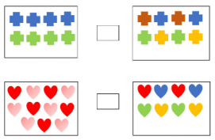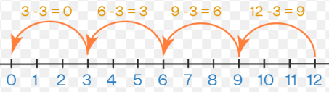

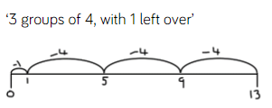

Mental Methods
Recognise the commutative law doesn’t work
Recall 10 division facts from number sentence flashcards
Recall 5 division facts from number sentence flashcards
Recall 2 division facts from number sentence flashcards
Double TO digits that don’t bridge
Double O digits that bridge
Double TO digits that bridge

Written Methods
Count back in 2s, 5s and 10s and a numbered number line
Count back in 2s, 5s and 10s on an empty number line (with steps given)
Count back in 2s, 5s and 10s on an empty number line
Show division questions as repeated subtraction onto a number line
Represent O ÷ O multiplication questions as arrays

Division
Year 3
National Curriculum Objectives | Key Vocabulary
- recall and use division facts for the 3, 6, 4, 8, 11 multiplication tables  - write and calculate mathematical statements for division using the multiplication tables that they know, including for two-digit numbers times one-digit numbers, using mental and informal written methods (e.g. partitioning/chunking)  - solve problems, including missing number problems, involving division, including positive integer scaling problems and correspondence problems in which n objects are connected to m objects.  NO FORMAL WRITTEN METHOD FOR MULTIPLICATION | - Skip Counting  - Repeated Subtraction  - Divide  - Share  - Halving  - Equal  - Unequal  - Remainder  - Left Over  - Divisor

Key Manipulatives and Images

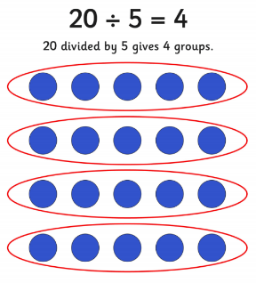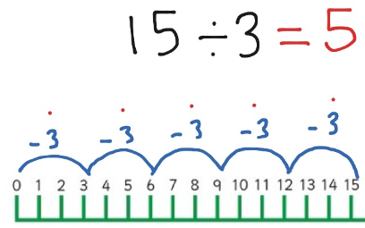
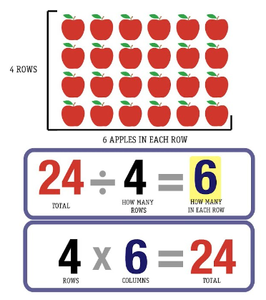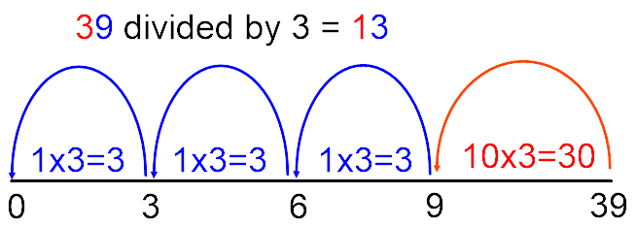

Mental Methods
Recognise the commutative law doesn’t work for division
Recall 11 division facts from number sentence flashcards
Recall 3 division facts from number sentence flashcards
Recall 6 division facts from number sentence flashcards
Recall 4 division facts from number sentence flashcards
Recall 8 division facts from number sentence flashcards
Link division facts (fact families) for the 11s, 3s, 6s, 4s, 8s (12÷4 = 3 so 120÷4 = 30 and 120÷3 = 40)

Written Methods
Count back in 11s, 3s, 6s, 4s and 8s on a numbered number line
Count back in 11s, 3s, 6s, 4s and 8s on an empty number line (with steps given)
Count back in 11s, 3s, 6s, 4s and 8s on an empty number line
Show division questions as repeated subtraction on a number line
Represent O ÷ O multiplication questions as arrays
Represent TO ÷ O multiplication questions as an array
TO ÷ O using partitioning without bridging
TO ÷ O using partitioning without bridging

Division
Year 4
National Curriculum Objectives | Key Vocabulary
- recall division facts for multiplication tables up to 12 × 12  - use place value, known and derived facts to divide mentally, including: dividing by 1  - divide two-digit and three-digit numbers by a one-digit number using mental and informal written methods  NO FORMAL WRITTEN METHOD FOR MULTIPLICATION | - Skip Counting  - Repeated Subtraction  - Divide  - Share  - Halving  - Equal  - Unequal  - Remainder  - Left Over  - Divisor  - Dividend

Key Manipulatives and Images

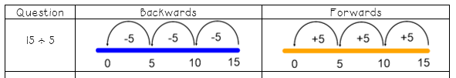

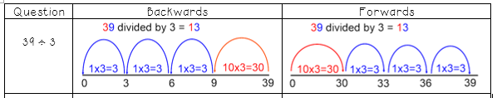
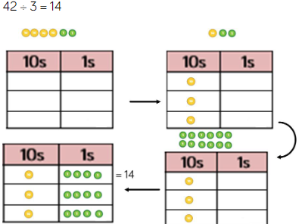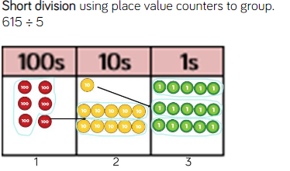
Mental Methods
Recognise the commutative law doesn’t work
Recall 9 division facts from number sentence flashcards
Recall 7 division facts from number sentence flashcards
Recall 12 division facts from number sentence flashcards
Link times table facts (fact families) for the 9s, 7s, 12 (27 ÷ 9 = 3 so 270÷9 = 30 and 270÷30 = 90)
Recall dividing by 1
Recall dividing by 0

Written Methods
Count back in 9s, 7s on a numbered number line
Count back in 9s, 7s on an empty number line (with steps given)
Count back in 9s, 7s on an empty number line
Show division questions as repeated subtraction on an empty number line
Represent O ÷ O multiplication questions as arrays
Represent ‘remainders’ as r?
Represent TO ÷ O multiplication questions as an array
TO ÷ O using partitioning where there isn’t a remainder
HTO ÷ O using partitioning where there isn’t a remainder
TO ÷ O using partitioning where there is a remainder
HTO ÷ O using partitioning where there is a remainder

Division
Year 5
National Curriculum Objectives | Key Vocabulary
- establish whether a number up to 100 is prime and recall prime numbers up to 19  - divide numbers mentally drawing upon known facts  - divide numbers up to 4 digits by a one-digit number using the formal written method of short division and interpret remainders appropriately for the context  - divide whole numbers and those involving decimals by 10, 100 and 1000  - solve problems involving division including using their knowledge of factors and multiples, squares and cubes  - solve problems division and a combination of these, including understanding the meaning of the equals sign  - solve problems involving division, including scaling by simple fractions and problems involving simple rates | - Repeated Subtraction  - Divide  - Share  - Equal  - Unequal  - Remainder  - Left Over  - Divisor  - Dividend

Key Manipulatives and Images

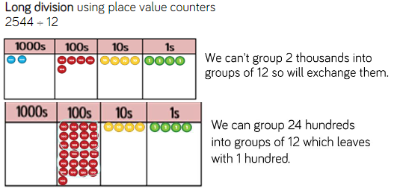

Mental Methods
Recognise that commutative law doesn’t work for division
Recall all division facts from flashcards
Link times division facts (fact families) for all tables
Link times division facts (fact families) for all tables with a focus on decimal links
Divide whole numbers by 10, 100, 1000
Divide decimals numbers by 10, 100, 1000

Written Methods
Revisit TO ÷ O using partitioning where there isn’t a remainder
Revisit HTO ÷ O using partitioning where there isn’t a remainder
Revisit TO ÷ O using partitioning where there is a remainder
Revisit HTO ÷ O using partitioning where there is a remainder
Represent remainders as a fraction
TO ÷ O using the formal written method (bus stop)
HTO ÷ O using the formal written method (bus stop)
ThHTO ÷ O using the formal written method (bus stop)
Represent remainders as a decimal
Decimals ÷ O using the formal written method (bus stop)

Division
Year 6
National Curriculum Objectives | Key Vocabulary
- divide numbers up to 4 digits by a two-digit whole number using the formal written method of long division, and interpret remainders as whole number remainders, fractions, or by rounding, as appropriate for the context  - divide numbers up to 4 digits by a two-digit number using the formal written method of short division where appropriate, interpreting remainders according to the context  - solve problems division  - use estimation to check answers to calculations and determine, in the context of a problem, an appropriate degree of accuracy  - perform mental calculations, including with mixed operations and large numbers  - use their knowledge of the order of operations to carry out calculations involving the four operations | - Repeated Subtraction  - Divide  - Share  - Equal  - Unequal  - Remainder  - Left Over  - Divisor  - Dividend

Key Manipulatives and Images

Mental Methods
Recognise the commutative law doesn’t work
Link division facts (fact families) for all tables
Link division facts (fact families) for all tables with a focus on decimal links
Divide whole numbers by 10, 100, 1000
Divide decimals numbers by 10, 100, 1000

Written Methods
Revisit Year 5 Division skills
Divide whole numbers by O using the formal method (bus stop)
Divide decimal numbers by O using the formal method (bus stop)
Divide whole numbers by TO using the formal method (bus stop)
Divide decimal numbers by TO using the formal method (bus top)
Divide whole and decimal numbers using factor pairs (double decker bus)

