Attendance & Punctuality Policy

Delegate Function: FGB

Approved by Governors: December 2022

Updated: November 2022

Review date: Autumn 2023
This policy/document was reviewed by:-  Signed………………………………………………………………………………………………  Position…………………………………………………………………………………………….  Signed.…………………………………………………………………………………………….  Position.………………………………………………………………………………………….. |  | Date:  Date:

Dee Point Primary School
Attendance & Punctuality Policy including EBSN (Emotionally Based School Non-Attendance) 2022/23
Introduction and Aim

Dee Point Primary School recognises the importance of good attendance and the impact it has on children’s progress, attainment, enjoyment of learning and relationships within school. Good attendance helps a child to realise their potential and ensure they are motivated, confident and enjoy a diverse range of curricular opportunities and experiences. Our school policy and prospectus promote good attendance, which is recognised and rewarded as an achievement. The school monitors attendance and ensures quick and early intervention if a problem is identified. We recognise that whole school preventative and proactive approaches are key to promoting pupil wellbeing and attendance. A pupil must attend school every day that they are required to do so unless an exceptional circumstance applies.
Our policy is accessible to leaders, staff, pupils, and parents/carers, and is published on our school website. It will be sent to parents with any initial information when pupils join the school and reminded of it at the beginning of each school year and when it is updated. As the barriers to attendance evolve quickly, the policy should be reviewed and updated as necessary. In doing so, we will seek the views of pupils and parents/carers. The Attendance & Punctuality Policy is based on the premise of equal opportunities for all.

- Legislation

Regular and punctual attendance at school is a legal requirement. Regular attendance is essential to enable pupils to maximise their educational attainment, opportunities and further development.
- Section 7 of the Education Act 1996 states that “The parent of every child of compulsory school age shall cause him/her to receive efficient full-time education either by regular attendance at school or otherwise”.
- Section 444 (1) of the Education Act 1996 states that “if a child of compulsory school age who is a registered pupil at a school fails to attend regularly at the school his parent is guilty of an offence”.
- Section 576 Education Act 1996 - Meaning of “parent”

For the purposes of Education Law, the definition of a ‘parent’ and who is responsible for ensuring regular attendance to school is:
- all biological parents, whether they are married or not
- any person who, although not a biological parent, has parental responsibility for a child or young person - this could be an adoptive parent, a step-parent, guardian or other relative
- any person who, although not a biological parent and does not have parental responsibility, has care of a child or young person. This could be one parent, both parents and/or carer/s.

- Registers

Registers provide the daily record of attendance of all pupils. They are legal documents and the register may be required in a court of law, for example as evidence in prosecutions for non-attendance in school.

‘Education (Pupil Registration) (England) Regulations 2006’ (section 6)
Schools must take the attendance register at the start of the first session of each school day, morning (a.m.) and once during the second session, afternoon (p.m.).

On each occasion, they must record whether every pupil is:
• Present
• Attending an approved educational activity
• Absent
• Unable to attend due to exceptional circumstances.

The school should follow up any absences to:
• Ascertain the reason
• Ensure the proper safeguarding action is taken
• Identify whether the absence is approved or not; and,
• Identify the correct code to use before entering it on to the school’s electronic register, or management information system as a priority and returned to the school office in a timely manner. This is used to download data to the School Census.
- Consider early identification, assessment, intervention and support processes that may need to be implemented.

The register should be marked using the codes as advised by the Department for Education (DfE) ‘Working together to improve School Attendance Guidance’ (for maintained schools, academies, independent schools and local authorities) https://assets.publishing.service.gov.uk/government/uploads/system/uploads/attachment_data/file/1073616/Working_together_to_improve_school_attendance.pdf

- Procedure

Pupils are expected to attend school regularly, unless there is good reason for absence.
There are two types of absence:
- Authorised (where the school approves a pupil absence)
- Unauthorised (where school will not approve the absence)

The school has a duty to safeguard all its pupils. If a pupil is absent, the parents/carers should inform the school on the first day of absence and each following day of absence, stating the reason.
Parents and carers need to contact the Attendance Manager on the following telephone number 01244 372631-option 1 or email attendance@deepointprimary.cheshire.sch.uk
The name and contact details of the senior leader responsible for the strategic approach to attendance in school is Dave Williams head@deepointprimary.cheshire.sch.uk
The Attendance Manager will make contact with home when a child is absent, and the parent/carer has not notified the school of the absence. If no contact can be achieved on day 1 and the pupil returns to school, a letter is sent (Letter 1) requesting reasons for absence to establish whether the absence is authorised or not. The response from parents and carers is requested to be within 5 days.
If the absence continues without contact for 3 consecutive days a letter is sent to parents and carers to ascertain the reason for absence. Following this, if school have not heard from home regarding the absence and the absence continues, then the school will do a home visit, as this will become a safeguarding concern. If a pupil is absent for more than 3 days and a home visit is unsuccessful, school will consider this to be a safeguarding concern. If contact is not made within 10 days the pupil will be classed as a Child Missing in Education and the local authority will be informed so it can be escalated.
The expectation from school regarding absences of more than 3 days due to illness is that parents and carers seek medical advice and use this as evidence for school to support and authorise the absence.

What can parents/carers do to help and working in partnership with Parents/Carers

Let the school know straight away, why your child is absent. Home/school communication is
extremely important in supporting your child to achieve and feel settled in school. Parents and carers need to make any routine dental/GP appointments outside of school time.

It is imperative that school and parents/carers work together with a shared plan and outcomes when supporting pupils’ attendance and wellbeing. If, despite persistent attempts to work with parents, there continues to be a lack of engagement, then legal procedures may be followed to secure engagement and school attendance

As a school, we recognise that building respectful relationships with families and working in collaboration is essential to ensuring the best outcomes for pupils. We require all parents to actively support the work of the school, including promoting attendance and engagement. We are committed to ensuring that systems and processes are in place with regards to promoting attendance and would encourage parents to make contact if they have concerns about their child.

We will provide parents/carers with information about Emotionally Based School Non-attendance to discuss needs and strategies to support their child, as appropriate (see EBSN Parent Leaflet).

- Absence Monitoring

School robustly monitor and analyse attendance data to promptly identify and address possible concerns and allow for early interventions to support the pupil/family underlying needs. This will include –
- Weekly attendance code analysis
- Specific cohort and group monitoring – particularly for vulnerable groups
- ‘Welcome back’ meeting for all pupils that have been absent for 5 days – to check wellbeing and ensure there are no ongoing needs that will impact on attendance
- The school’s strategy for using data to target attendance improvement efforts to the pupils or pupil cohorts who need it most.
- The school’s strategy for reducing persistent and severe absence, including how access to wider support services will be provided to remove the barriers to attendance and when support will be formalised in conjunction with the local authority.

- Early Identification and Intervention: assess, plan, do and review

Every pupil has a right to a full-time education and Dee Point Primary School sets high attendance expectations for all pupils. Dee Point Primary School will consider the individual needs of pupils and their families who have specific barriers to attendance and will consider our obligations under the Equality Act 2010 and the UN Convention on the Rights of the Child.
For any pupil who is absent from school it is essential to fully understand the reasons for this so that targeted, evidence-based interventions and support can be put into place. All staff have a part to play in promoting attendance. We recognise the importance of ensuring that key members of staff from across the school, including attendance, pastoral and SEND staff work in collaboration to consider and identify the holistic needs of the pupil and to overcome barriers to attendance. In accordance with the principles of early intervention, a graduated approach of assess, plan, do and review will be followed utilising a range of school-based resources, evidence-based interventions and seeking advice and support from external services at an appropriate stage, when needed.

Appropriate assessments will be important to help understand the underlying reasons that may be contributing to attendance difficulties. This may be an assessment that focuses on the individual pupil’s needs such as an SDQ, SEND assessments and wellbeing assessments or may include the holistic needs of the family, such as a TAF assessment. Assessments will include the views of the pupil as well as parents/carers, and identify strengths (what is working well) and needs (what is working less well).

Assessments undertaken may identify that a pupil is experiencing underlying emotional based needs that are contributing to non-attendance. Cheshire West and Chester Council has developed guidance for schools - Emotionally Based School Non-attendance: Good practice guidance for schools (revised November 2021). This is a whole school framework with a graduated approach to support the early identification and intervention of pupils who may struggle to cope in school/attend school.

Information from assessments will inform a SMART action plan with focussed targets developed in partnership with families and other services as appropriate. For example, Early Help and Prevention and Social Care may have a part to play in the delivery of support and intervention to promote engagement and attendance. SMART plans should be personalised to effectively meet a pupil’s needs and improve attendance and wellbeing outcomes.

Regular reviews of support and attendance plans are essential to monitor the impact of interventions and to adjust these accordingly. If, despite targeted support and intervention, attendance and wellbeing concerns persist, we may seek further advice and support from external services including mental health services, specialist teaching and education services.

- Medical Absence

Absence due to sickness should be reported to the school by phone or email on the first day of absence. The school should be kept informed during longer periods of absence. School will contact parents/carers during the first day if no satisfactory reason for absence has been received or if we have not heard from parents/carers.

Any medical absences in excess of 5 days (10 sessions) per academic year will need to be supported by medical evidence. If no medical evidence is received, then the absence may be recorded as unauthorised. The school will work with all families on an individual basis if medical absences
exceed the maximum threshold.

If a medical absence is likely to be ongoing or long term, then we will offer support in accordance with the school’s policies and statutory guidance relating to Children with health needs. https://www.gov.uk/government/publications/supporting-pupils-at-school-with-medical-conditions--3. As a school we need to plan how children can access Education and how and when the child will return to school. In accordance with the Equality Act 2010 the school must also demonstrate that reasonable adjustments are made to meet pupil’s Educational Needs.
For pupils who have a medical condition and cannot attend school, the school will refer to the Cheshire West and Chester Council’s Medical Needs Team. https://www.cheshirewestandchester.gov.uk/documents/education-and-learning/medical-needs-service/medical-needs-policy-latest.pdf

Their policy states that referrals must come directly from the child’s school and must be supported by medical evidence from one of the following health professionals:
- consultant paediatrician or adolescent psychiatrist
- consultant child psychiatrist
- hospital consultant
Supporting evidence from a General Practitioner alone cannot be accepted.
- Lateness and Punctuality

School begins at 9.00am for all pupils and they are expected to be in school for registration at that time.
- Register taken at 9.00am for all year groups
- Registers close at 9.15am for all year groups

Any pupil who arrives after the gates are closed must enter the school by the main entrance and report to the school office to sign in. If pupils are not in class when the register is taken, they will be coded as ‘L’. Any late arrivals after 9.15am will be coded as ‘U’, which is an unauthorised absence for that session.

In accordance with the ‘Education (Pupil Registration) (England) Regulations 2006’, if your child arrives after the registers close, they will receive a mark, code U, that shows them to be on site, but this will not count as a present mark and it will mean they have an unauthorised absence. This may mean that you could face the possibility of a Fixed Penalty Notice or other legal action if the problem persists.

Pupils who are consistently late for school are disrupting not only their own education, but also that of other pupils. Where persistent lateness gives cause for concern, you will be invited to a meeting to resolve the issues. If there is no improvement following this meeting, further action will be taken which may include referral to external agencies.
You may approach the school at any time for support and advice if you are having difficulty getting your child to school on time or maintaining regular attendance.

- Unauthorised Absence and Fixed Penalty Notice

An absence may be coded as ‘unauthorised’ if:
    - no reason for absence has been given
    - medical evidence is not received when requested
    - a request for a leave of absence has been unauthorised
    - a pupil arrives at school after registration has closed at 9.00am for Reception through to Year 6.

Parents/carers should be aware that Dee Point Primary School will contact the Local Authority if a pupil has 10 or more unauthorised absences in the current term with a view to issuing a Fixed Penalty Notice or other legal action. The Fixed Penalty Notice is issued individually to each parent/carer who fails to ensure their child’s regular attendance at school. The Penalty is £60 per parent/carer per child if paid within 21 days rising to £120 if paid within 28 days. Non-payment of the Fixed Penalty Notice may result in prosecution in the Magistrates court (see appendix 1).

- Application for Exceptional Circumstances

In September 2013, amendments to the Education (Pupil Registration) (England) Regulations 2006, make it clear that Head Teachers may not grant any Leave of Absence (holiday) during term time unless there are ‘exceptional circumstances’

The Head Teacher and the Governing Body will determine what constitutes an exceptional
circumstance on an individual basis. It should be noted that if any application is declined and absence occurs of a consecutive 5 or more unauthorised days, then school may apply to the Local Authority for a Fixed Penalty Notice to be issued to each parent/carer.

The following will not be deemed to be exceptional circumstances:
- Family holiday
- Availability of less expensive holiday
- Availability of holiday accommodation
- Parent/carer’s working commitments
- Holiday pre-booked by another family member

A pupil’s absence during term time seriously disrupts their continuity of learning. Not only do they miss the teaching on the days they are away but are less prepared for the lessons building on that teaching when they return to school. There is a consequent risk of under achievement, which we must seek to avoid.
The Governing Body is responsible for ensuring any attendance issues are dealt with in line with school policy.

- Religious Observance

We recognise that some pupils may need to participate in days of religious observance.
Where a day of religious observance.

- falls during school time and
- has been exclusively set apart for religious observance by the religious body to which the pupil belongs
We ask that parents/carers notify Dee Point Primary School in writing in advance where absence is required due to a religious observance.

- Enforced School Closure

If Dee Point Primary School was forced to close for a period of time, we have the facility to operate an online virtual school. The expectation is pupils will still engage with ALL activities when work is set. Procedures for online learning will be sent to parents/carers as and when required.

- Impact
All pupils will achieve well by developing knowledge and skills on their journey through school. Due to robust monitoring of attendance, all pupils, including vulnerable pupils and pupils with special educational needs and disabilities (SEND), will have fair and equitable access to school in order to achieve the best possible outcomes. Pupils will leave Dee Point Primary School ready for a successful transition to secondary education.

Appendix 1
Dee Point Primary School Attendance Flow Chart
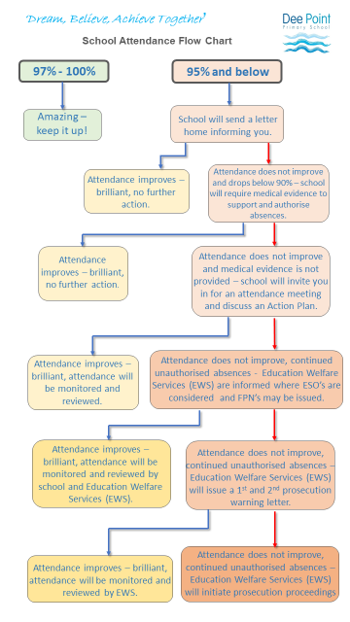
Cheshire West & Chester
Code of Conduct for Education Fixed Penalty Notice (Unauthorised Leave of Absence & Irregular
Attendance)

1. A Fixed Penalty Notice (FPN) can only be issued in cases of unauthorised absence.
2. A maximum of two FPNs may be issued in an academic year and these FPNs may be issued against each parent/carer of a child. Once two FPNs have been issued, should there be further unauthorised absences, the Local Authority are able to move to prosecution immediately.
3. A FPN may be issued per parent per child.
4. Penalty Notices may be considered appropriate if:
- Unauthorised absences of at least 10 consecutive school sessions (five school days).
- Sessions either side of a weekend or school holiday will be counted as consecutive school days.
- For poorly attending learners, at least 10 sessions (five school days) lost due to unauthorised absence during a school term. These do not need to be consecutive.
- For poorly attending learners, persistent late arrive at school in a term. Persistent means at least 10 sessions of late arrival.
- The presence of an excluded child in a public place in the child’s first five days of exclusion.
6. The school must notify parents of the Attendance Policy and clearly state that parents may receive an FPN for an unauthorised leave of absence relating to holiday in term time.
7. Schools and the Education Welfare Services will take into account any exceptional circumstances when determining whether to issue an FPN.

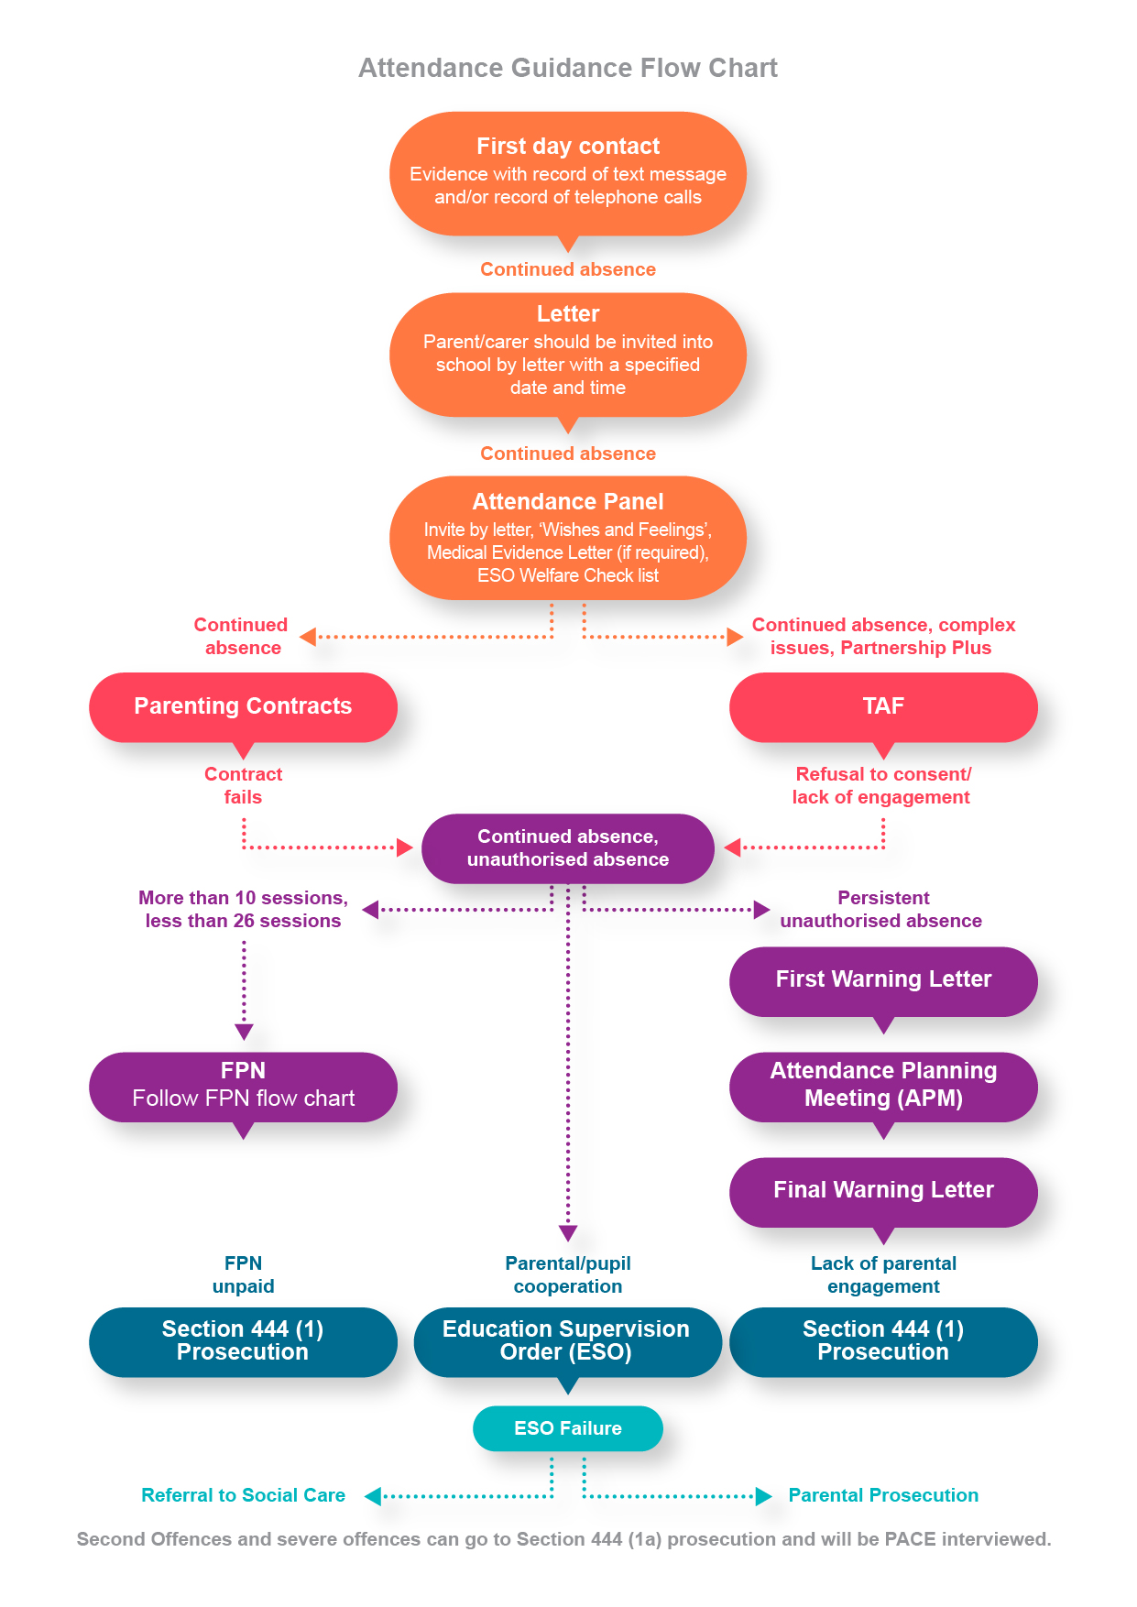

Emotionally Based School Non-attendance (EBSN)
Emotionally Based School Non-attendance (EBSN) is a term used to describe the needs of CYP who struggle to attend school due to underlying emotional based needs, such as anxiety, unhappiness and despair. These CYP may be reluctant to leave home and can present high levels of distress in response to parents’ attempts to get them to school. This can result in prolonged absences from school.
EBSN is complex and multifaceted, requiring a holistic approach to assessment and intervention. Good practice guidance emphasises the importance of early identification and intervention to support the needs of CYP who may struggle to attend school, developing a SMART support plan, with timely review processes (CW&C, 2018).
The EBSN framework is embedded within the school’s Attendance Policy and we use many of the tools and resources to underpin our early identification of need and targeted support and intervention approach.
Schools can access EBSN training and Guidance (EBSN: Good Practice Guidance for Schools) via: eCWIP for Education - Cheshire West Industry Professionals

