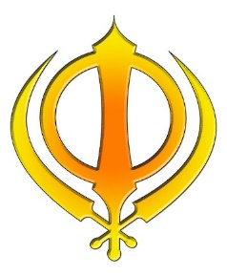
KNOWLEDGE ORGANISER
Why is community and equality important to Sikhs?

Key Vocabulary
5 Fingers | Sikhism, Sikh, Guru Granth Sahib, Punjabi, Gurmukhi, Gurdwara
Guru Nanak | Guru Nanak was the founder of Sikhism and is the first of the ten Sikh Gurus.
Guru Granth Sahib | Guru Granth Sahib is the holy book of Sikhism.
Gurmukhi | Sikh scripts- this is the language the the Guru Granth Sahib is written in.
Panth and Khalsa | Khalsa refers to both a community that considers Sikhism as its faith, as well as a special group of initiated Sikhs. The Khalsa tradition was initiated in 1699 by the last living Guru of Sikhism, Guru Gobind Singh.  Panth is the terms used for several religious traditions in India. They are founded by a Guru or an Acharya.
5Ks | The 5Ks, are five items that Guru Gobind Singh commanded Khalsa Sikhs to wear at all times. They are: Kesh (uncut hair), Kangha (a wooden comb for the hair), Kara (an iron bracelet), Kachera (100% ctton tieable undergarment) and Kirpan (an iron dagger large enough to defend oneself).
Gurdwara | A Gurdwara is the place where Sikhs come together for worship.
Guru | Teacher
Prior learning
Future Learning
- How do Sikhs worship? – Y5

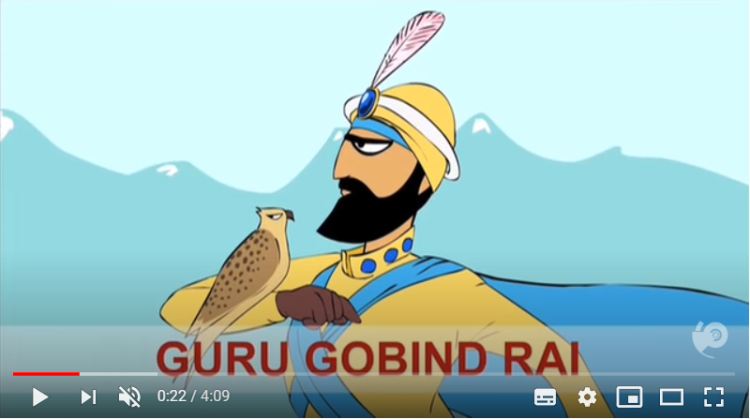
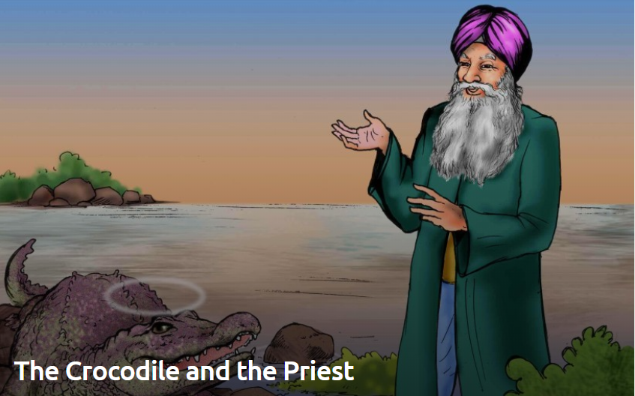
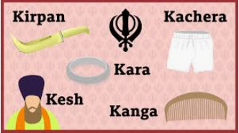
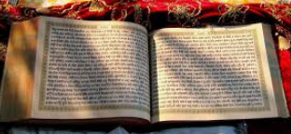
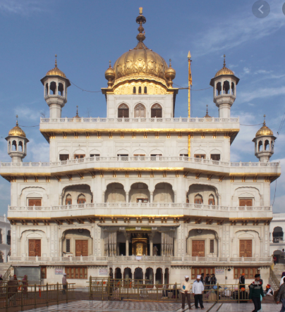
The crocodile and the priest
The Formation Of The Khalsa

Key Artefacts and Symbols

Key Stories

Our Enquiry Steps:
What do Sikhs believe?
Who is Guru Nanak and how did he become a teacher and leader?
What is the Guru Granth Sahib?
What is the symbolism of the 5Ks and why is the community important for Sikhs?
How do Sikhs lead their lives to the best of their ability?
How do Sikhs remember the birthday of Guru Nanak?

