Prior learning
- How and why are Allah and Muhhamed (PBUH) important to Muslims? – Y2
- How do Muslims express new beginnings? – Y2
Future Learning
- How is the Muslim faith expressed through family life? – Y5
KNOWLEDGE ORGANISER
Why are the Five Pillars important to Muslims?

Key Vocabulary
Belief | An acceptance that something exists or is true.
5 Pillars | The five basic rituals or obligations that evey Muslim must satisfy in order to live a good and responsible life according to Islam.
Shahadah | A key Islamic statement of faith – ‘There is no god but Allah, and Muhammed is his messenger.’ This is the first pillar of Islam.
Qur’an | The Islamic sacred book.
Wudu | Is the Islamic procedure for the cleansing parts of the body prior to prayer. Wudu involves washing the hands, mouth, nostrils, arms, head and feet with water.
Sawm | Sawm is the fasting. It’s the fourth of the Five Pillars of Islam. Muslims are required to fast during Ramadan.
Ramadan | Ramadan is the ninth month of the Islamic calendar, when Muslims fast during daylight hours.
Salah/Salat | Salah/Salat is the obligatory Muslim prayers, performed 5 times each day by Muslims. It is the second Pillar of Islam.
Zakah/Zakat | Zakat is the compulsory giving of a set of proportion of one’s wealth to charity. It is regarded as a type of worship and of self-purification. It is the third Pillar of Islam.
Hajj | Hajj is the Pilgrimage to Mecca. All Muslims who are physically able to must make this journey once in a lifetime.
Pilgrimage | A journey, especially a long one, made to some sacred plac as an act of religious devotion.

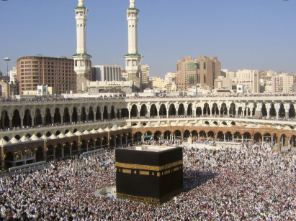
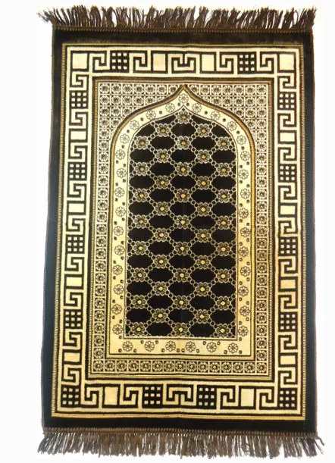
KS2 Religious Education - BBC Bitesize
Useful Links
Key Artefacts and Symbols
Our Enquiry Steps:
What are the Five Pillars of Islam?
What is the Shahadah?
How do Muslims prepare for prayer?
Why do Muslims fast? (Sawm)
What is the pattern of prayer for Muslims? (Salat/Salah)
How do Muslims show care for others? (Zakah)
Why do Muslims go on Pilgrimage? (Hajj)

