Prior learning
Future Learning
Who was Jesus and why is he important to Christians today? – Y2
Why do Christians think about Incarnation at Christmas? – Y4
Key Vocabulary
Nativity | A picture, carving, or model representing Jesus Christ's birth.
Gold | Gold is a precious metal and as such was a very valuable commodity.
Frankincense | Frankincense is a white resin or gum Frankincense was often used in worship, in the burning of incense, by the priests.
Myrrh | Myrrh is a spice which was commonly used in ancient times. It is made from sweet smelling sap which is obtained from several species of tree. The trees are found in parts of Africa and the Middle East, including Yemen and Ethiopia.
Angel | Angels are powerful, smart spirits that obey God's commands and praise him with singing. They sometimes appear to humans in human form
KNOWLEDGE ORGANISER
Why is Christmas celebrated by Christians?

Our Enquiry Steps:
What is meant by the idea of something 'precious'?
What happened before and after the birth of Jesus?
What was special about the gifts that were given to Jesus?
Which parts of the Christmas story are still good news for Christians today
Why do Christians believe that Jesus was a gift from God?
Can you discuss how the school nativity is different or similar to your understanding of the Christmas story?
Why do some adults choose to be baptised?
What is special about belonging?

Key Stories
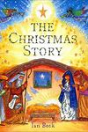

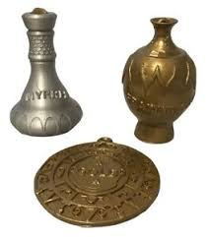
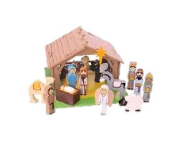
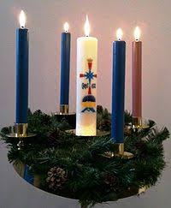
Key Artefacts and Symbols

