

**KNOWLEDGE ORGANISER**

**What can we learn from Christian religious buildings and music?**

**Our Enquiry Steps:**

What would I expect to find in Christian places of worship?

What would my local church want me to know about them?

Which piece of art or artefact from my local church can I find out more about?

How is music used in church?

How does the “Lord of the Dance” and “See what a morning” to the Gospel narratives of Easter?

How does the Christian communities demonstrate their beliefs through song and silence?

|  |
| --- |
| **Prior learning** |
| * What do I think about Jesus and how he is portrayed in art from around the world? – Y3 |
| **Future Learning** |
| * What are some of the differences and similarities within Christianity locally and globally? – Y6 |

**Songs/Music:**

The Lord’s Prayer - Hillsong Worship <https://www.youtube.com/watch?v=nCxqjEz5hJ4>

The Lord’s Prayer - African Sanctus <https://www.youtube.com/watch?v=J7f5cevDigI>

[The Lord's Prayer - Andrea Bocelli htps://www.youtube.com/watch?v=u8jImIjg4UY](https://www.youtube.com/watch?v=u8jImIjg4UY)

The Lord of the Dance <https://www.youtube.com/watch?v=214Vdyo6kSs>

See What a Morning <https://www.youtube.com/watch?v=-Qlc0UIRkBk>

Remember Me <https://www.youtube.com/watch?v=nhFBX5ZSySo>

Come and See <https://www.youtube.com/watch?v=y_8BZmWb2N8>

Christ the Lord is Risen Today <https://www.youtube.com/watch?v=jfNwvNhpkN4>

Sing Out an Easter Song—<https://www.youtube.com/watch?v=0YwlX49ie0E>

Merciful Saviour—One Hope Project <https://www.youtube.com/watch?v=915bhvKxres>

Blinded By Your Grace Stormzy -<https://www.youtube.com/watch?v=YsxBrb_uXNg>

Taixe—<https://www.youtube.com/watch?v=M-hybuhxJg8>

Will You Come and Follow Me—<https://www.youtube.com/watch?v=9EU55SVdjdE>

Laudate Dominum (Taizé Chant) <https://www.youtube.com/watch?v=mwRMT2_pi9c>

Jesus Remember Me (Chant) <https://www.youtube.com/watch?v=RGB2E0NzO2A>

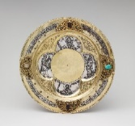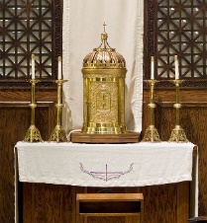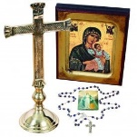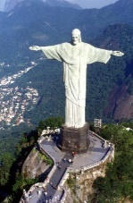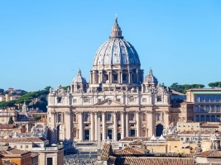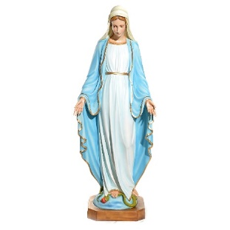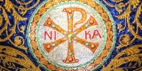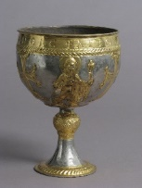

**Key Artefacts and Symbols**