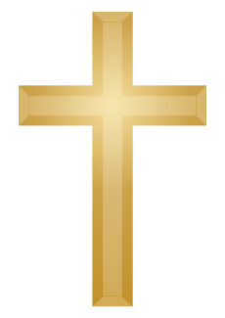
KNOWLEDGE ORGANISER
What concepts do we find hard to understand in Christianity?

Prior learning
- What is my point of view about God and why do people have faith? – Y3
Future Learning
Key Vocabulary
5 Fingers | Christianity, Christian, Bible, Hebrew, Aramaic, Greek, Church
Sin and Forgiveness | Sin is described as an act of offense against God by depressing his persons and Christian biblical law.  Forgivenes is a manifestation of submission to Christ and fellow believers.
Incarnation | ‘God became flesh’. It is the belief that God assumed a human nature and became a man in the form of Jesus Christ.
Messiah | Messiah in Christiantiy is the Son of God.
Emmauel | God with us.
Trinity | In the Christian religion the Trinity is an idea, used to explain that three different people were called God in the Bible; God the Father, God the Son and God the Holy Spirit.
Stations of the cross | a series of fourteen pictures or carvings representing successive incidents during Jesus's progress from his condemnation by Pilate to his crucifixion and burial, before which devotions are performed in some Churches.
Salvation | In Christianity, Salvation is the ‘saving of human beings from death and separation of God’.

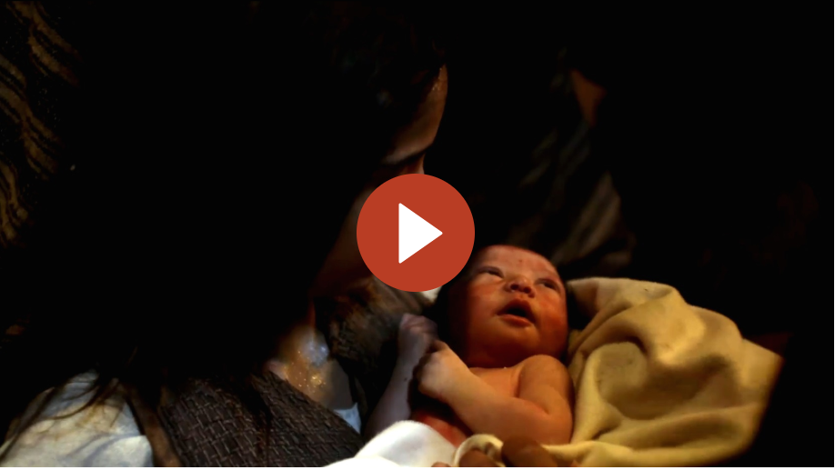
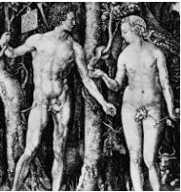
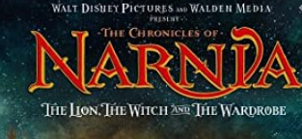
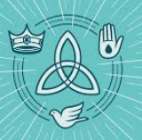
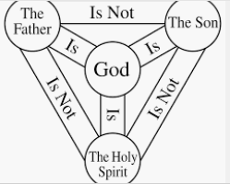
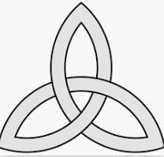
Mary’s Lullaby
The Lion, Witch and Wardrobe
Key Stories

Our Enquiry Steps:
How are the concepts of sin and forgiveness developed in The Lion, The Witch and The Wardrobe?
What examples can you use to explain the concept of the Trinity to others?
Can I describe the concepts of Saviour, Messiah and Emmanuel?
How are the Stations of the Cross used as an aid to prayer and reflection?
How would you explain the resurrection to others? What is your view on the resurrection?
Is Salvation a gift?
Key Symbols

Adam and Eve

