Prior learning
- Special days and festivals - EYFS
Future Learning
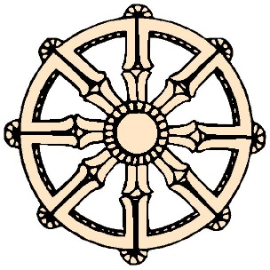
KNOWLEDGE ORGANISER
What is Buddhism?

Key Vocabulary
Siddhartha Gautama | - Founder of Buddhism
Meditation | - Sit and think quietly
Enlightenment | - Realise something amazing.
4 Noble Truths | - Buddha’s teachings to others.
Dharma | - Truth
Asala Dharma Day | - Celebrates the beginning of Budhism.
Karma | - The idea that actions have a consequence.
Temple | - Place of worship
Loy Krathong | - Festival of thanks.
Vesak | - Festival to celebrate Buddha’s life (Birthday)
Our Enquiry Steps:
How did Buddhism begin?
What are some key facts about Buddhism?
Where do Buddhists worship?
What symbols are important in Buddhism?
What is Loy Krathonmg and how is it celebrated?
What is Vesak and how is it celebrated?

Key Story
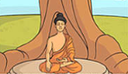

The story of Buddha
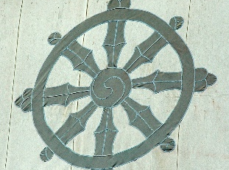
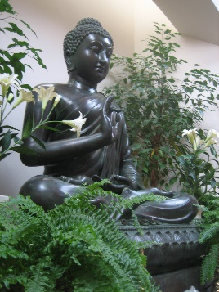
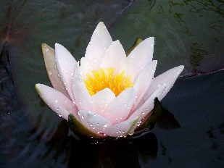
Key Artefacts and Symbols

