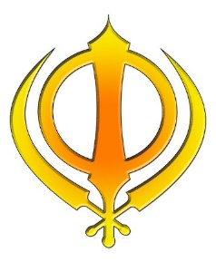
KNOWLEDGE ORGANISER
How do Sikhs worship?

Key Vocabulary
5 Fingers | Sikhism, Sikh, Guru Granth Sahib, Punjabi, Gurmukhi, Gurdwara
Gurdwara | A Sikh place of worship/ holy building.
Guru | A Hindu spiritual teacher.
Guru Granth Sahib | The Guru Granth Sahib, also called Adi Granth, is the holy book of the religion Sikhism.
Khanda | The symbol or emblem of Sikhism is known as the Khanda. It is made up of – a double edged sword. This represents the belief in one God.
Punjabi | Belonging or relating to the Punjab region of India or Pakistan, it’s people or it’s language.  Punjabi is the language spoken in the Punjab.
Gurmukhi | The script used to write the sayings of the Gurus and used to write the Punjabi language.
Langar | Free community kitchen in the Gurdwara for all visitors.
Pilgrimage | A journey to a special place that has religious or spiritual significance.
Rituals | A religious or solemn ceremony consisting of a series of actions performed according to a prescribed order.
Golden Temple | The holiest shrine of Sikhs also called the Harimandir. It is situated in the Punjab state.

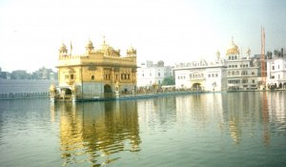
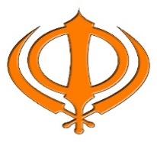
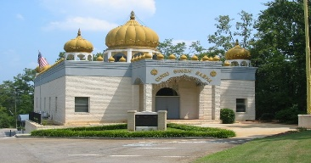
The Golden Temple
Key Artefacts and Symbols

Khanda
Prior learning
- Why is community and equality important to Sikhs? – Y4
Future Learning
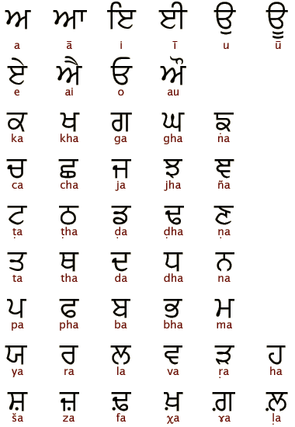
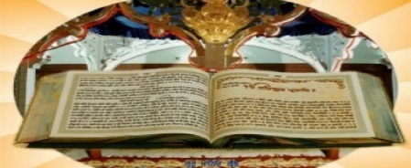
Gurmukhi
Guru Granth Sahib
Key Stories

Gurdwara
Our Enquiry Steps:
What is the Gurdwara? How is this important to the community?
What is the Khanda?
How do Sikhs worship in the Gurdwara?
Why so Sikhs have a Langar?
How do Gurdwaras look different or similar around the world? What is the Golden Temple like?
Can I introduce Sikhism to others making connections with my prior learning?

