KNOWLEDGE ORGANISER
How did Jesus teach about God and values through parables?

Prior learning
- Why is the Bible a special book for Christians? – Y2
- Who was Jesus and why is he important to Christians today? – Y2
Future Learning
- What is the Kingdom of God and what do Christians believe about the afterlife? – Y6
Key Vocabulary
Parable | A short story that teaches a moral or spiritual lesson especially : one of the stories told by Jesus Christ and recorded in the Bible.
Pharisee | Were members of a party that believed in resurrection and in following legal traditions that were ascribed not to the Bible but to “the traditions of the fathers.” Like the scribes, they were also well-known legal experts: hence the partial overlap of membership of the two groups.
Humility | Is an asset for self-improvement. By living a humble life, you recognize the areas of your life that need work. Proverbs 11:12 : When pride comes, then comes disgrace, but with the humble is wisdom. Clothe yourselves, all of you, with humility toward one another, for “God opposes the proud but gives grace to the humble."
Tax Collector | Is a person who collects unpaid taxes from other people or corporations. ... Tax collectors are often portrayed in fiction as being evil, and in the modern world share a similar stereotype to that of lawyers.
Pride | Means having a feeling of being good and worthy. ... They can be proud of something good that they have done. They can be proud of (or take pride in) their work. They might be proud of their son or daughter or husband or wife or anyone else who is close to them and who has done something good.
Persistence in Prayer | To persevere, not to give up but to continue to pray for the same thing. To be tenacious and determined in prayer.
Kingdom of God | In the simplest terms, the Kingdom of God is the rule of God. So wherever the Lord Jesus Christ reigns, there you have the Kingdom of God. ... It is the Spirit of God Who reveals the ways of God to the children of God (see John 14:26). It is one of the key elements of the teachings of Jesus in the New Testament. Drawing on Old Testament teachings, the Christian characterization of the relationship between God and humanity inherently involves the notion of the Kingship of God.
Gospel | The word gospel comes from the Old English god meaning "good" and spel meaning "news, a story." In Christianity, the term "good news" refers to the story of Jesus Christ's birth, death, and resurrection.

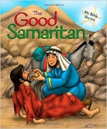
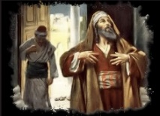
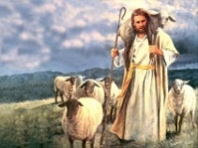
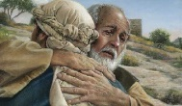
The Pharisees & The Tax Collector

The Lost Sheep

The Friend at Midnight

The Prodigal Son

Key Stories
Key Songs
The Sower Song
https://www.youtube.com/watch?v=_4o07d4Lp54
Tax Collector Song
https://www.youtube.com/watch?v=yxe9jO0scgA&list=TLPQMTQwNDIwMjBspQWKtAkguA&index=3
Our Enquiry Steps:
Why did Jesus teach about God through parables?
How was Jesus explaining about pride and humility through the Parable of the Tax Collector and the Pharisee?
Can you explain how the parable of the Tax Collector and the Pharisee teaches about being closer to God
What does the Parable of the Friend at Midnight teach a Christian about prayer?
How does the Parable of the Judge and the Widow explore the relationship between a Christian and God?
What is the Kingdom of God and how does the mustard seed help to explore this concept?

