Prior learning
- Why is the Bible a special book for Christians?– Y2
- Who was Jesus and why is he important to Christians today? – Y2
Future Learning
- How do Christians use the Bible to help them with their lives? – Y3
- How did Jesus teach about God and values through parables? – Y4
KNOWLEDGE ORGANISER
Why did Jesus teach people through stories?

Key Vocabulary
5 Fingers | Christianity, Christian, Bible, Hebrew, Aramaic, Greek, Church
Parables | A very short story told to teach a moral or religious lesson.  Jesus' parable of the Good Samaritan teaches us that it is as important to help strangers as it is to help friends.
Welcome | Used to express warm greetings to someone who has just arrived.  Welcome! We are glad you are here. The Parable of the Lost sheep teaches we are all welcome and important to God.
Foundations | The act of beginning or establishing. A house built on a strong foundation will last many years. What conditions did the plants need to grow well? The importance of good preparation before sowing seed. What sort of foundations do you want to build your life on.
Influences | A thing or person that has the power to affect another. Who influences your foundations?
Forgiveness | The act of forgiving. The father was delighted to see his son return home. How does this help us to understand about a Christian’s relationshio with God as a Father?
Neighbour | Another human. Someone who shows kindness to another, even a stranger.

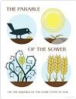
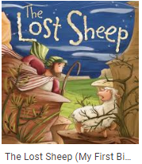
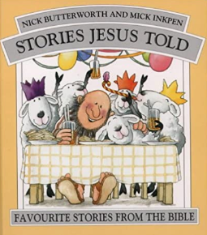
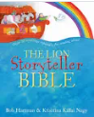
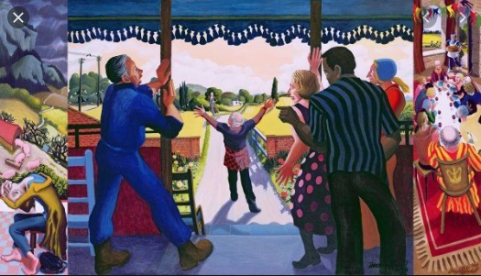
Key Artefacts and Symbols
Key Stories
Our Enquiry Steps:
What does the Parable of the Lost Sheep teach Christians about God?
What is the message from Jesus in the Parable of the Sower?
What do Christians mean when talking about building good foundations in the Parable of the Parable of the Two Builders.
How does the Parable of the Prodigal Son teach about God?
How does the Parable of the Good Samaritan teach about Christian love? What does it mean to love your neighbour?
What parables can I tell to others?

