Prior learning
Future Learning
- How do Muslims express new beginnings?– Y1
- How do Muslims worship? – Y3
- How is the Muslim faith expressed through family life? – Y5
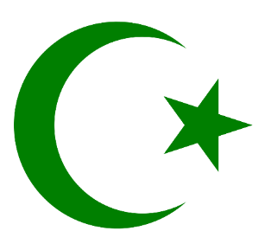
KNOWLEDGE ORGANISER
How and why are Allah and Mohammed (PBUH) important to Muslims?

Key Vocabulary
5 Fingers | Islam, Muslims, Qur’an, Arabic, Mosque
Allah | Allah is the Arabic word for God – whom Muslims worship,
Islam | The second most popular religion in the world.
Mohammad (pbuh) | The founder of Islam. Muslims say he is a messenger from God and is the last of the prophets.
Muslim | Someone who follows Islam. Muslims believe that there is only one God, Allah.
Prophethood | Muslims believe that Prophets are messengers sent from God, or Allah, to help Muslims follow the straight path.
Qur’an | The Qur’an is a book in the Arabic language that Muslims believe to be the actual words of Allah.

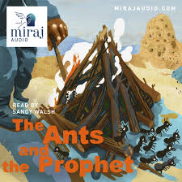
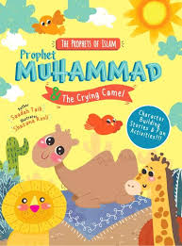
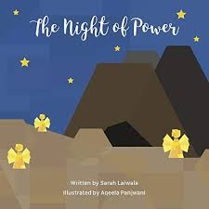
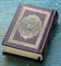
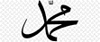
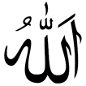
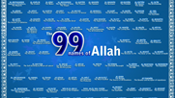
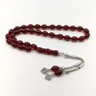
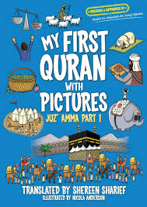
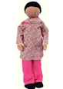
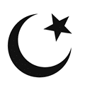
Key Stories
Key Artefacts and Symbols
Our Enquiry Steps:
What is a Muslim?
Who was Muhammad?
What happened to Muhammad on the Night of Power?
Who is Allah?
How do Muslims describe Allah?
What are some of the 99 names?

