Prior learning
- How and why are Allah and Muhhamed (PBUH) important to Muslims? – Y2
- How do Muslims express new beginnings? – Y2
Future Learning
- Why are the Five Pillars important to Muslims? – Y5
- How is the Muslim faith expressed through family life? – Y5
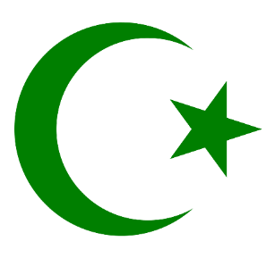
KNOWLEDGE ORGANISER
How do Muslims worship?

Key Vocabulary
Prophet | An important teacher sent by God.
Revelation | Realise something important
Qur’an | The Qur’an is a book in the Arabic language that Muslims believe to be the actual words of Allah.
Mohammad (pbuh) | The founder of Islam. Muslims say he is a messenger from God and is the last of the prophets.
PBUH | Praise Be Upon Him
Angels | Muslims believe Angels were created by Allah (God) to follow his orders and communicate with humans.
Mosque | Muslim place of worship.
Calligraphy | Decorative handwriting.
Wudu | Washing before handling the Muslims Holy Book
Respect | Attitude towards the feelings, wishes or rights of others.
Word of Allah | These were recorded by Muhammed in the Qur’an.

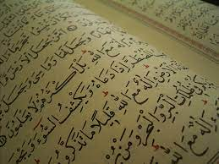
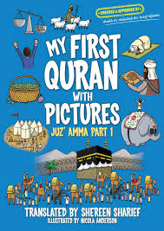
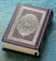
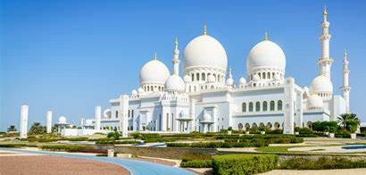
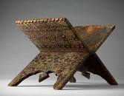
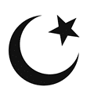
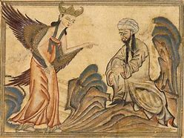
Our Enquiry Steps:
What can you remember about Islam? Who spoke to Muhammad in the cave?
What do Muslims believe about Angels?
Where do Muslims worship?
How is art used to express belief in Islam?
How do Muslims prepare to pray?
What do Muslims believe about the Qur’an?
Key Artefacts and Symbols
Muhammad, Jibril and the cave
Key Stories

