Prior learning
- How and why are Allah and Muhammed (PBUH) important to Muslims?– Y1
Future Learning
- How do Muslims worship? – Y3
- Why are the Fiver Pillars important to Muslims? – Y5
- How is the Muslim faith expressed through family life? – Y5
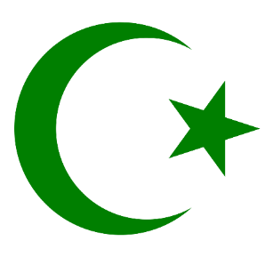
KNOWLEDGE ORGANISER
How do Muslims express new beginnings?

Key Vocabulary
Wudu | Washing before handling the Muslims Holy Book
Qur’an | The Qur’an is a book in the Arabic language that Muslims believe to be the actual words of Allah.
Arabic | The language the Qur’an is written in.
Creation | How the world was made.
Shahadah | Tells you what you believe as a Muslim – there is one God called Allah and Muhammad is his messanger.
Mohammad (pbuh) | The founder of Islam. Muslims say he is a messenger from God and is the last of the prophets.
Allah | Allah is the Arabic word for God – whom Muslims worship.
Adhaan/Adhan | Special ceremony where special words are spoken to a new baby.
Wedding | Ceremony where two people get married.
Nikah | The name given to the wedding ceremony.
Islam | The second most popular religion in the world.
Muslim | Someone who follows Islam. Muslims believe that there is only one God, Allah.
Mosque | Muslim place of worship.
Hijab | A head covering worn by some Muslim women as a way of honouring their beliefs.

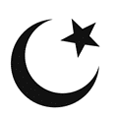
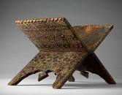
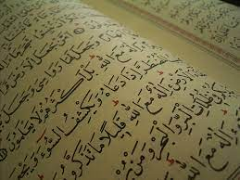
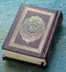
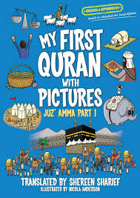
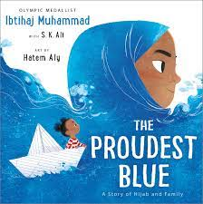
Key Artefacts and Symbols
Key Stories
Our Enquiry Steps:
What is the Holy Book of Islam?
What do Muslims believe about Creation? How does this compare to the Christian story of Creation?
What is the Shahadah?
How is a baby welcomed into a Muslim family?
What happens at a Muslim wedding?
What are some of the important words for Muslims which express their faith?

