Emotionally Based School Non-attendance (ESBN): Information for Parents
Emotionally Based School Non-attendance (ESBN) is a term used to describe the needs of
children and young people who have difficulty attending school due to high levels of worry or anxiety. This can often result in prolonged absence from school.

Children may report feeling unwell (e.g. stomach-ache or nausea etc.) and may express negative thoughts such as ‘I can’t cope’ or ‘I can’t do it’. Naturally, children will try to avoid these uncomfortable feelings by not going to school. Whilst this feels better for a short time, it makes it harder to face up to going to school the next day, and in the longer term.

The more a child/young person stays off school, the more worried they will usually feel about going.

You have been given this leaflet as there are signs that your child may be struggling to attend school / experiencing ESBN. Your role is essential when working with school to help your child to overcome their current difficulties and to help get them back to regular school attendance.

Good school attendance is associated with more positive educational outcomes, career prospects and general life opportunities.

3 key things to keep in mind:
- Understanding anxiety and why attending school may feel difficult: anxiety is the feeling of fear or panic. It is a normal response to a perceived or real threat. Everyone will feel worried or anxious at some point in their life. Children may worry about a school trip, exam or starting a new class. Whilst a certain level of worry is normal, excessive worrying or anxiety can become a problem, especially when it stops children from doing what they want or need to do.
Signs of anxiety may include: crying, refusing (e.g. to get out of bed, to get dressed, to leave the house), sleep difficulties, negative thinking and worry about school-related issues, becoming withdrawn (e.g. not speaking, staying in their room), reports of feeling unwell (e.g. headaches, stomach-aches, “I feel sick”, “My heart is racing”) but no underlying medical cause.
Learning to manage worry is part of growing up. Help your child to share their worries and discuss ways to address these together with school.

- Promote a positive coping approach: focus on what’s going well, aspects of school they enjoy and skills they are learning to get better at e.g. “You managed it yesterday. You can do it today. It will get easier”.

- Keep attending school / a small steps approach (facilitate exposure): generally, the longer the period of absence from school, the harder it can be to return. Additional worries can also occur, such as falling behind in schoolwork, changes in friendships, reduced self-esteem and self-belief. It is important to help your child to address any worries as soon as possible and to try and keep going to school.

The diagram below shows how EBSN behaviours can develop:
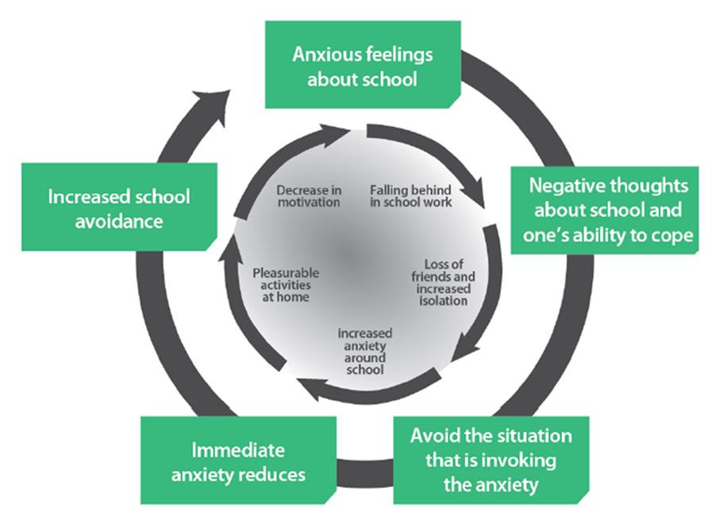
A small steps approach can help your child to gradually build back up to full attendance with good support and reasonable school adjustments. This may include sitting in the car in the car park for X minutes, going into the building and sitting in a quiet room, meeting a Key Adult your child feels ‘safe’ with for a fun activity, attending a sports activity or some favourite lessons.

What can I do?
- Ensure a united and consistent approach – all family members to use the same approach.
- Maintain consistent routines and good organisation at home - everyone gets anxious when they’re rushing or if you can’t find things etc. Ensure that your child:
- gets to bed at a reasonable time
- has the necessary clothes and equipment ready for school the night before
- gets up in good time
- washes, dresses for school and eats breakfast
- is ready by the time they ought to leave home for school.
Encourage your child to take responsibility for this routine. For example, give them an alarm clock or a visual morning schedule.
- Be supportive yet firm. If your child says they feel unwell and you think they are well enough to attend school, show that you understand how they might be feeling but remain firm that they need to attend school every day. School will monitor your child and contact you if needed.
- Keep calm and model confidence: if you seem worried or frustrated, your child will pick up on this. Be like a swan – gliding along serenely on the surface (even though your feet are paddling away furiously under the water).

- Give clear and positive messages about school attendance:
Vague messages about school attendance | Clear messages about school attendance
“Are you going to school today?”  “Don’t worry. There’s nothing to be scared of. It will be okay.”  “Why are you doing this? You’re upsetting the whole family.”  “Dad and I don’t know what to do if you won’t go.”  “If you can’t get there today, it’s only going to be harder tomorrow.” | “I’ve asked you already. It’s time to get up for school.”  “Dad and I will do whatever we have to in order to get you to school.”  “We cannot allow you to remain at home.”  “I know this is hard, but it has to happen. You have to go to school.”  “Today after school, we can go … (something they like, e.g. go and play in the park, go and get pizza for dinner, play with….).”  “You have five minutes to get dressed for school.”  “I can see that you feel upset about going to school, but you still have to go. Tell me what you are worried about, so we can talk about it.”

- Focus on the positives: help your child to reflect upon the things that they enjoy and that go well. Ask: ‘what are you most looking forward to in school today?’; ‘tell me three things that were good in school today.’
- Try different ways of travelling to school e.g. go in the car instead of walking, riding a bike instead of using the bus, a different family member escorting to school. Also consider asking one of your child’s friends to call for them each morning to travel to school together. Use distraction techniques en route e.g. playing a game such as I-Spy or listening to favourite music.
- Help your child to talk about their worries and the things that they find hard, and to think of ways to address these (problem-solve). For example, “If (the worst) happens, what could you do?” or “Let’s think of some ways you could handle that situation.” This gives an opportunity to coach your child on how to manage specific situations.
- Positively reward facing feared situations: lots of praise for ‘facing the fear and doing it anyway’.
- Maintain regular communication with school: have a key person or two who you can contact (emails, texts or phone calls) so that both school and home are aware of what’s going on. Also encourage your child to keep in touch with friends and school during periods of non-attendance e.g. ask them to email their work to their Classteacher.
- Take your child to see your doctor to eliminate the possibility of medical illness. Tell the school as soon as you suspect that stomach-aches or headaches may be symptoms of worry / anxiety rather than an underlying medical issue.
- If your child is not attending school, keep the same routines in place as if he/she were attending e.g same getting up time, put on and wear school uniform during the day. Refuse access to TV, mobile telephone, computer games or other home entertainment until after the learning day is over. Do encourage your child to socialise with friends after school hours.
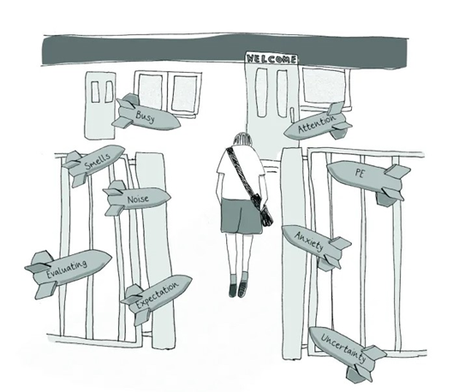
- Meet with school to discuss your child's wellbeing and attendance, and the factors affecting your child’s ability to cope. Discuss what might help make your child to feel safe and less worried in school. Agree a support plan (eg. Support and Attendance Plan) including actions at home and at school that may help (eg. agreed morning routine, a parent joining their child at breakfast club, a daily ‘meet and greet’, identified ‘safe base’ or a weekly session with a learning mentor; if not in school, no access to entertainment devices during the school day). The support plan should be regularly reviewed (initially fortnightly) to check that all steps are having a positive impact.
- Worries and anxieties about school are not uncommon. You are not on your own. There are professionals who can help you and it will get better with time.

The long-term goal is for your child to return to school full time. The goal will probably be achieved by a series of small steps. At times it may feel like two steps forward and one step back – keep positive and take heart that you are moving in the right direction.

